Architecture Design Document

FinTech_P2P_Lending - LendSetu

< Vaibhav Wadkar>

Architecture Design Document
Architecture Document is the high-level description of the system, showing its fundamental work principles. The primary purpose of this documentation is to correlate functional and non-functional requirements.
Purpose
The software architecture document provides a comprehensive overview of the software system's architecture. It serves as a communication medium between the software architect and other project team members regarding architecturally significant decisions that have been made on the project.
Timing
The Software Architecture Document is primarily developed during the elaboration phase because one of the purposes of this phase is to establish a sound architectural foundation.
Responsibility
The software architect is also responsible for maintaining the architectural integrity of the system through the development process by:
- Approving all changes to architecturally significant elements, such as major interfaces, described in the Software Architecture Document.
- Being part of the "change-control board" decisions to resolve problems that impact the software architecture.
Tailoring
The software architect is also responsible for maintaining the architectural integrity of the system through the development process by:
- Approving all changes to architecturally significant elements, such as major interfaces, described in the Software Architecture Document.
- Being part of the "change-control board" decisions to resolve problems that impact the software architecture.
Considerations while Writing a Design Document
- Keep it Simple – Simple words, simple sentences, bulleted lists/ numbered lists
- Include charts and diagrams as appropriate. Remember to add a link to the editable version of the diagram under the screenshot, so you can easily update it later when things inevitably change.
- Include numbers- Factual
- Do the Sceptic Test - Before sending your design doc to others to review, take a pass at it pretending to be the reviewer. What questions and doubts might you have about this design? Then address them pre-emptively.
- Ensure the document has – Clarity, Completeness, Concise, Correctness & Facts.
Reference For the Documentation: https://arc42.org/overview
Architecture Design Document Template
Document Review and Version Control
Sl no. | Date of Creation | Version No. | Author(s) | Reviewer(s) | Approver | Comments
1 | 27/07/2025 | 1.0 | Vaibhav Wadkar
2 | 23/08/2025 | 1.1 | Vaibhav Wadkar |  |  | Replacing bullet points with numbers, Addition of description, 4th Section Design Analysis
3 | 03/09/2025 | 1.2 | Vaibhav Wadkar |  |  | Addition of ADRs, Architecture diagram, Sequence diagram
4 | 27/09/2025 | 1.3 | Vaibhav Wadkar |  |  | Added High Level Architecture, Deployment View, ERD, Risks & Technical Debts
5 | 02/10/2025 | 1.4 | Vaibhav Wadkar |  |  | Cross Cutting Concepts
6 | 27/10/2025 | 1.5 | Vaibhav Wadkar |  |  | AI Security & Compliance were added under Crosscutting Concepts
7 | 10/11/2025 | 1.6 | Vaibhav Wadkar |  |  | Reduction in ADR’s length, Data Flow Credit Scoring added, API & Ecosystem Interfaces Design added, How the new system is better than the existing one added
8 | 23/11/2025 | 1.7 | Vaibhav Wadkar |  |  | Architecture update – Kubernetes, Real time fraud detection, Sec 10 – Quality Requirement
Contents
1. Introductory Section 5
1.1. Requirements Overview 5
1.2. Quality goals 5
1.3. Stakeholder 5
2. Architectural Constraints 6
3. Context and Scope 6
3.1 Business Context 6
3.2 Technical Context 6
4. Solution Strategy 6
5. Building Block View 7
5.1. Whitebox Overall System 7
5.2. Level 2 7
5.2.1 White Box Block 1 7
6. Runtime view 8
7. Deployment View 8
7.1 Infrastructure Level 1 8
7.2 Infrastructure Level 2 8
8. Crosscutting Concepts 8
9. Architecture Decisions 8
10. Quality Requirements 8
10.1 Quality Requirements 8
10.2 Quality Scenarios 8
11. Risks & Technical Debt 9
12. Glosary 9

< FinTech_P2P_Lending - LendSetu>

Introduction and Goals

LendSetu is an online P2P lending platform through which people in need of personal loans are connected with those who want to lend money. The whole process is covered: sign-up is completed, documents are checked, loans are applied for, approval is given using AI, money is accepted, repayments are made in monthly instalments, and everything is tracked. The main aim is for borrowing and lending to be made easier, safer, and clearer for everyone involved.

Requirements Overview

The main goal is for a website and app to be created in India where money can be lent and borrowed directly between people without the involvement of a traditional bank. The process is intended to be made easier, faster, and better for everyone. All rules set by the Reserve Bank of India (RBI) must also be followed.
The following capabilities are required for the platform:
- Easy Sign-Up:
1.1: A sign-up form for borrowers and a separate form for lenders must be provided by the platform.
1.2: Essential information, including full name, email address, and a valid mobile number, must be captured during the sign-up process.
1.3: A One-Time Password (OTP) must be sent by the system to the user’s mobile number for verification.
1.4: A secure password must be created by the user for their account.
- Check Identities (KYC):
2.1: Secure upload of digital copies of government-issued identification documents (e.g., Aadhaar card, PAN card) must be facilitated by the platform.
2.2: An internal workflow must be triggered by the system for review and approval/rejection of documents by a dedicated team.
2.3: The KYC status of the user must be updated in real-time on their dashboard (e.g., "Pending," "Verified," "Rejected," “Proposed”).
- Online Loan Application:
3.1: A digital loan application form must be accessible and completed by borrowers.
3.2: Details such as loan amount requested, purpose of the loan, and income information must be collected by the form.
- Smart Loan Approvals:
4.1: A third-party credit bureau must be integrated with the system to fetch the borrower’s credit score.
4.2: The borrower’s credit history, financial data, and other inputs must be analysed by the AI engine to generate a risk score.
4.3: Based on the risk score, a fair and appropriate interest rate must automatically be proposed by the system.
- Lenders Choose Loans:
5.1: A list of all approved loan requests, excluding personally identifiable borrower information, must be accessible to lenders.
5.2: Each loan request displayed on the lender’s dashboard must include the AI-provided "lender score" to support decision-making.
5.3: The exact amount to be contributed to a specific loan request must be specified by lenders.
- Money In, Money Out:
6.1: A secure fund disbursement from the nodal/escrow account to the borrower’s bank account must be automatically triggered once a loan is fully funded.
6.2: A recurring debit for the borrower’s monthly EMI must be automatically initiated by the system on the scheduled date.
6.3: Collected principal and interest amounts must be automatically distributed by the system to the corresponding lenders’ accounts.
- Keep Track:
7.1: A dashboard must be provided by the platform for borrowers to track the real-time status of their loan application and repayment schedule.
7.2: A dashboard must be provided by the platform for lenders to track their investment portfolio, including loan statuses and payment histories.
- Skip a Payment (Sometimes):
8.1: A formal request to skip one monthly EMI must be allowed to be submitted by borrowers.
8.2: The EMI schedule must be programmatically adjusted by the system to account for the skipped payment.
8.3: The borrower’s internal platform credit score must automatically be updated to reflect the use of the payment holiday.
- Follow RBI Rules:
9.1: A special nodal/escrow bank account must be used by the system for all financial transfers, as mandated by the RBI.
9.2: Lending and borrowing limits as defined by the RBI must be enforced and monitored by the platform.
9.3: A mechanism must exist within the platform to regularly share loan and repayment data with recognized Credit Information Companies (CICs).

Quality Goals

The success of the LendSetu platform is considered to hinge not only on its features but also on the robustness of its underlying architecture. The most critical quality goals have been defined to guide every design and implementation decision so that the platform is secured, reliability is ensured, and preparedness for future growth is achieved.
- Compliance (Regulatory Adherence as per RBI):
1.1: Mandatory data reports must be generated and submitted to the RBI in the specified format and frequency through an automated system.
1.2: All fund movements—disbursements and repayments—must be enforced by the architecture to be processed exclusively through the approved nodal/escrow bank account, without any funds being held by the platform itself.
1.3: Lending and borrowing caps for all users must be programmatically enforced by the system as mandated by the RBI, and any transactions exceeding these limits must be automatically rejected.
1.4: An immutable and tamper-proof audit trail of all transactions and key user actions must be maintained by the platform for a minimum of ten years, as required by law.
- Security (Data & Transaction Integrity):
2.1: All sensitive data, including PII (Personally Identifiable Information), financial details, and documents, must be encrypted both at rest (in databases and storage) and in transit (using HTTPS/TLS).
2.2: A Role-Based Access Control (RBAC) model must be implemented by the system so that users and internal staff are restricted to accessing only authorized data and functions.
2.3: A real-time fraud detection system must be included in the platform so that transaction patterns are analysed and suspicious activities are alerted to the security team.
2.4: Regular third-party penetration testing must be undergone by the system so that vulnerabilities can be identified and addressed.
- Scalability (Performance Under Load):
3.1: Stateless microservices must be used to compose the architecture so that they can be deployed and scaled horizontally (by adding more instances) to handle increased user traffic and transaction volume.
3.2: A load balancer must be placed to distribute incoming traffic evenly across multiple service instances so that no single instance becomes a bottleneck.
3.3: Database queries must be optimized and indexed so that a high volume of concurrent requests can be handled without performance degradation.
3.4: Long-running, resource-intensive tasks (e.g., generating reports, sending bulk emails) must be handled asynchronously so that main user-facing services are not blocked.
- High Availability (Uninterrupted Service):
4.1: All critical components and services must be deployed with redundancy across multiple availability zones within the cloud provider’s Indian region.
4.2: Automated failover mechanisms must be included in the system so that a service failure is detected and traffic is seamlessly rerouted to a healthy instance without manual intervention.
4.3: A formal Disaster Recovery (DR) plan must be put in place so that business continuity is ensured in the event of a major regional outage.
4.4: An overall uptime target of 99.99% must be achieved by the platform, translating to no more than 52.56 minutes of downtime per year.
- Maintainability & Flexibility (Adaptability to Change):
5.1: A modular, microservices-based design must be used to build the system so that features and components can be updated, replaced, or removed without impacting the rest of the system.
5.2: Clean coding practices must be adhered to, and code must be well-documented with clear comments and API specifications.
5.3: A comprehensive suite of automated tests (unit, integration, end-to-end) must be put in place so that new code does not introduce bugs.
5.4: Cloud-agnostic technologies (e.g., Docker containers) and infrastructure-as-code principles must be used in the design so that migration of the platform to a different cloud provider can be carried out if required.

Stakeholder
The different groups of people by whom the LendSetu platform will be used or affected, along with their expectations, are described as follows:
- Lenders: As providers of capital, expectations are centred around security, transparency, and return on investment. A secure environment for money to be invested, clear and comprehensive information about potential loans, and a reliable system through which timely repayment of principal and interest is ensured are expected.
- Borrowers: As recipients of capital, a seamless and fair process is expected. An easy-to-navigate loan application process, transparent and competitive interest rates, quick access to funds upon approval, and a straightforward way to manage repayments are expected. Crucially, personal and financial data are expected to be handled with the utmost privacy and confidentiality.
- Approvers (Our Team / AI): This group, which includes both human loan officers and automated systems, requires efficient and reliable tools so that borrower risk can be assessed, documents verified, and loan approvals or rejections made. Accurate and auditable risk scores are required to be provided by the AI system to support these decisions.
- Management (Leaders / Dashboard): A high-level view of platform performance is required by the leadership team. Comprehensive dashboards with key metrics such as the total value of loans disbursed, the number of active users, and platform profitability are expected. This information is considered vital for strategic business decisions and for ensuring compliance with regulatory reporting requirements.
- Development Team (Tech Team): Responsibility for building and maintaining the platform is held by this team. Clear and well-defined project plans, access to robust development tools, and a well-structured architecture allowing efficient system development, management of technical debt, and quick responses to new requirements are expected.
- RBI (Reserve Bank of India): As the primary regulator, strict adherence to all rules governing online lending in India is required. Consumer protection, financial stability, and fraud prevention in the P2P lending sector are expected outcomes.
- Credit Check Companies (Third Party): Agencies such as CIBIL provide essential credit history data. Smooth integration with their APIs for retrieving borrower credit reports and for submitting loan disbursement and repayment data, as mandated by the RBI, is expected. This ensures borrowers are prevented from exceeding lending limits across P2P platforms.
- Escrow / Nodal account in Bank: All funds are required to be held and transferred through this specialized account, as mandated by RBI regulations. Precise and secure instructions for disbursements and repayments are expected so that transaction accuracy and security are ensured.
- Payment Companies: Companies such as payment gateways facilitate money transfers. Seamless and reliable API integrations with their systems are expected so that smooth and uninterrupted financial transactions for all users are ensured.
- Other Financial Companies: These include banks and FinTech businesses interested in partnership. Secure, well-documented APIs enabling easy and effective system-to-system integration are expected so that new business opportunities can be opened.
- Collection Agency: In cases where a borrower defaults, a clear process for engagement with a third-party collection agency is expected. Assistance in the recovery of outstanding funds, in compliance with legal and ethical guidelines, is required to be provided by the agency.

Architectural Constraints

The non-negotiable, fixed rules and limitations to be followed when the LendSetu platform is designed and built are listed below. These rules are treated as the boundaries of the project, and through them, all legal, regulatory, and technical requirements are ensured from the outset.
- RBI License Required: The platform is required to be officially registered as an NBFC-P2P (Non-Banking Financial Company – Peer to Peer Lending Platform) with the Reserve Bank of India (RBI). Operation is not permitted without this license. This constraint is regarded as a critical driver for all other design decisions, particularly those concerning compliance and security.
- Only a Matchmaker: The role of the platform is restricted to connecting lenders and borrowers. Lending of its own money, guaranteeing loans, or holding deposits like a bank is not permitted. The platform is strictly an intermediary.
- Online Focus on Web & App only: Development of the platform is to be carried out exclusively as a web application and a mobile application. No in-person or physical branch presence is permitted, thereby simplifying operational and architectural design.
- Fast Money Transfer: The payment infrastructure is required to be designed to facilitate rapid movement of funds. All transfers into and out of the escrow account must be completed quickly, ideally within one business day (T+1).
- Fixed Fees Only: The revenue model of the platform is restricted to charging a fixed amount or a fixed percentage of the loan value. Performance-based fees (e.g., fees that increase if a borrower defaults) are prohibited, simplifying both business logic and compliance reporting.
- No Extra Sales: Sale of any products or services beyond loan-related insurance is not permitted. This restriction simplifies business logic and maintains the platform’s core focus.
- Share Data with Credit Systems: Loan and repayment data are required by law to be reported regularly to official credit information companies in India (e.g., CIBIL). Robust integrations with these third-party systems must therefore be included in the architecture. This also ensures adherence to the RBI rule limiting a borrower’s total borrowing amount across all P2P platforms.
- Only for India: Use of the platform is restricted to the Indian market. This restriction simplifies legal compliance and data residency requirements, since only one set of national regulations must be followed.
- KYC Regulations: Government-approved methods (e.g., Aadhaar and PAN) must be used by the system for identity verification. All verification steps and results are required to be meticulously logged and made auditable to meet regulatory scrutiny.
- Data Residency: All user data, including personal information, documents, and transaction records, is required to be stored within datacentres located in India. This is treated as a critical security and compliance constraint.
- Infrastructure Location: Regardless of whether deployment is carried out on-premises or on a cloud platform, all physical infrastructure must be based in Indian regions to comply with data residency laws.
- Non-Functional / Quality Constraints:
  - Service Level Objectives (Availability)
    - Availability: ≥ 99.9% uptime
    - Response time: ≤ 2 seconds for UI operations
  - Security Standards (Security)
    - TLS encryption in transit and Encryption at rest
    - Role-Based Access Control
  - Backup and Recovery (Reliability)
    - Daily backups
    - Recovery Time Objective (RTO) ≤ 40 min
    - Recovery Point Objective (RPO) ≤ 15 min

Context and Scope
This section is used to explain where the platform is placed in the bigger picture. What is done by the system, who it is connected to, and what its boundaries are is shown here.

Business Context

The Peer-to-Peer Lending Platform is described as an online marketplace for loans in India.
- What we do: Two main groups of people are connected:
  - Borrowers: People who need money.
  - Lenders: People who want to lend money to earn interest.
- Our role: A middleman role is played, but not in the manner of a bank. Loan applications are facilitated for borrowers, their credit is checked, and loan requests are displayed to lenders. Once a loan has been agreed upon, the disbursement of money and the repayment process are managed by the platform.
- Why we exist: A simpler and faster way for people to obtain loans or diversify their money is offered in comparison with traditional banks. Low and competitive interest rates, reduced documentation, flexible terms of up to three years, transparency, and full control (including lending, borrowing, and rejection), as well as no penalties on prepayments and no collateral requirements, are provided.
- Our rules: All activities are guided by the strict rules of the Reserve Bank of India (RBI).

Technical context

The platform is described as a modern, online system that has been built using cloud technology.
- How it is accessed: The website or mobile app is used by people to interact with the platform.
- How it is Hosted: The system is run on cloud infrastructure (such as Google Cloud, Amazon Web Services, or Microsoft Azure). In this way, handling of many users and easy growth are enabled.
- Who it communicates with (other systems): Several outside services are required to be connected with the platform:
  - Identity Check Services: Users are confirmed through government-approved systems (e.g., Aadhaar).
  - Credit History Companies: Information about a borrower’s past loans and repayments is obtained (e.g., CIBIL).
  - Special Bank Accounts (Nodal / Escrow): All money for loans and repayments is required to flow through a special, secure bank account managed by a trustee bank, as mandated by the RBI.
  - Payment Systems: Actual movement of money between bank accounts is carried out (e.g., UPI, NEFT, RTGS).
  - Message Services: Emails and SMS notifications are sent.
  - Collection Agency: In cases of borrower default, a collection agency is contacted for recovery.
- Sharing with Partners: Special connections (APIs) are created so that integration with systems of other financial companies can be enabled for business partnerships.

Solution Strategy

This section is used to explain the main decisions and strategies chosen for building the platform, with a focus placed on the core strategies selected to achieve the business and quality goals.

Technology Decisions

The platform is to be built using a modern web stack so that cross-platform accessibility and rapid development are ensured:
- Backend & Core Logic: The platform’s "engine" (the backend) will be built using programming languages such as Python and Node.js. These languages are considered suitable to ensure smooth operation and the handling of many users at once.
- Data Storage: PostgreSQL (OLTP) will be used as the main database for storing important, organized information such as user accounts and loan details. Also, it supports ACID properties too. Another type of database, MongoDB, may also be used for other forms of data, such as activity records of users on the site or user logs. Redis which is a in-memory cache to improve speeds for session management and frequently accessed data. Amazon S3, where Object storage for large unstructured data like KYC documents, contracts, logs but storage will be immutable. RedShift, used as Read Replica of PostgreSQL so all read & report generation request will get diverted to this database so that PostgreSQL load will get reduced. RedShift DB is optional in case of initial MVP product.
- Infrastructure: The platform will be hosted on a public cloud (e.g., Amazon, Google, or Microsoft).
    - Containerization: Applications and their dependencies will be packaged using Docker.
    - Orchestration: Deployment, scaling, and load balancing of containers will be managed by Kubernetes.
    - Managed Services: Managed database services, message queues (e.g., SQS, Pub/Sub, Kafka), and object storage (S3, GCS) will be utilized so that operational overhead is reduced.
    - CI/CD Pipelines: GitHub Actions, Jenkins, GitLab CI to automate build, test, and deployment workflows.
    - Security:
- OAuth2 / OpenID Connect: Standard for authentication and authorization.
- JWT (JSON Web Tokens): For stateless, scalable user session identification.
- Encryption: AES-256 for data at rest, TLS for in transit.
- Key Management Service (KMS): Cloud-based encryption key lifecycle management.
- Multi-factor Authentication (MFA) and biometric integration for enhanced security.
- Monitoring and Logging:
  - Prometheus + Grafana: Real-time monitoring of service health and metrics visualization.
  - ELK Stack (Elasticsearch, Logstash, Kibana): Centralized storage and analytics of logs, security auditing.
  - Distributed Tracing: Jaeger / Zipkin for request flow and bottleneck analysis.
- Frontend: A web application will be developed using React so that a dynamic and responsive user experience is provided across web and mobile browsers.
- AI and Machine Learning: Using TensorFlow / PyTorch / Scikit-learn used for building AI-powered credit risk scoring models, predictive analytics, loan default forecasting.
- External Integrations:
- Credit Bureaus: CIBIL, Experian, Equifax, CRIF High Mark API integration for credit score fetching.
- Payment Gateways: Razorpay, PayU, Paytm for payment and escrow management.
- Government APIs: Aadhaar, PAN verification for KYC compliance.
- Communication Services: AWS SNS/SES for transactional SMS and emails.

Top-Level Decomposition

The architecture of the system will be based on the Microservices Architectural Pattern.
- Each part of the platform, such as user registration or loan applications, will be developed as an independent microservice. In this way, work on one part can be carried out without breaking another (e.g., User Management, KYC, Payment & Collections, etc.).
- An API Gateway will be used as the public-facing “main door,” through which API management, security, and request routing to the appropriate backend services will be centralized.

- Communication between services will primarily be handled through asynchronous, event-driven mechanisms using a central message queue. By this approach, services are decoupled, fault tolerance is enhanced, and flexible, non-blocking workflows are enabled.

- Each service will maintain its own data so that a problem in one service will not cause the entire system to shut down.

To achieve key quality goals
The following key quality goals are mapped to specific scenarios, solution approaches, and references to details. By these approaches, fulfilment of the platform’s non-functional requirements derived from stakeholder needs (e.g., secure transactions, high availability, etc.) is ensured.
- Quality goal: Compliance
Scenario: The system must enforce RBI-mandated lending and borrowing limits for all users and report data to regulatory bodies.
Solution approach: We will implement a dedicated Compliance and Limits Enforcement microservice that validates every transaction against the regulatory caps before it is processed.
Link to Details: 21: Regulatory Limits Enforcement

- Quality goal: Compliance
Scenario: All funds must be managed through an RBI-approved escrow account without ever being held by the platform.
Solution approach: The platform will integrate via secure APIs with an RBI-approved bank that provides escrow services, with all fund flows orchestrated by a dedicated payment service.
Link to Details: 11: Escrow Account - Third-Party Integration

- Quality goal: Compliance
Scenario: All user data and platform infrastructure must be stored within India to comply with data residency laws.
Solution approach: We will deploy the platform exclusively to a public cloud provider's region located within India, ensuring all data resides within the country's borders.
Link to Details: 03: Data Residency - In-Country Hosting

- Quality goal: Security
Scenario: We need to protect all sensitive data from both external and internal threats.
Solution approach: We will implement a Zero Trust Security Model where every request is authenticated and authorized, regardless of its origin. All sensitive data will be encrypted both at rest and in transit, tokenization of Aadhaar/PAN, OAuth2/OIDC for identity management.
Link to Details: 22: Data Encryption at Rest and In Transit, 08: Authentication & Authorization, 12: Encrypt PII & Tokenize Aadhaar/PAN

- Quality goal: Security
Scenario: We need a stateless and scalable way to authenticate users across our microservices.
Solution approach: The system will use JSON Web Tokens (JWT) for authentication, allowing the API Gateway to validate user identity without hitting a database on every request.
Link to Details: 08: Authentication & Authorization

- Quality goal: Security
Scenario: We need a single source of truth for all user identities to prevent inconsistencies and security risks.
Solution approach: A dedicated User Management microservice will centralize all user-related data and authentication logic, with other services communicating with it to verify identity.
Link to Details: 16: User Identity - Centralized Service

- Quality goal: Scalability
Scenario: The platform needs to handle a significant increase in user volume and transaction traffic.
Solution approach: The system is built with a Microservices Architecture, allowing us to scale specific components (e.g., the loan application service or payment engine) horizontally by adding more instances as demand grows.
Link to Details: 01: Microservices over Monolith Architecture

- Quality goal: Scalability
Scenario: We need to avoid cascading failures and performance degradation when a high-volume event occurs.
Solution approach: Services will communicate asynchronously using a message queue or event bus. This decouples services and allows the system to handle bursts of events without overwhelming individual components.
Link to Details: 04: Data Management - Asynchronous Communication

- Quality goal: Scalability
Scenario: We need to ensure incoming user requests are distributed evenly across all service instances.
Solution approach: We will implement a Layer 7 Load Balancer in front of our services to intelligently distribute traffic and prevent any single instance from becoming a bottleneck.
Link to Details: 23: Load Balancing Strategy

- Quality goal: High Availability
Scenario: A hardware failure or an entire datacentre goes down.
Solution approach: All critical services are deployed with redundancy across multiple Availability Zones (AZs). We use automated health checks and failover to seamlessly reroute traffic to a healthy instance.
Link to Details: 25: Redundancy Across Availability Zones, 26: Automated Health Checks and Failover

- Quality goal: High Availability
Scenario: The primary database instance fails.
Solution approach: We will use database replication in a primary-secondary configuration. If the primary instance goes down, a replica will automatically take over, ensuring continuous data availability.
Link to Details: 027: Database Replication

- Quality goal: High Availability
Scenario: A major regional disaster takes down the entire cloud region.
Solution approach: We have a formal Disaster Recovery (DR) plan with a standby environment in a different geographic region that can be activated to ensure business continuity.
Link to Details: 28: Implementation of a Disaster Recovery Plan, 03: Data Residency - In-Country Hosting, 13: Continuous Integration/Continuous Deployment (CI/CD) (Kubernetes)

- Quality goal: High Availability
Scenario: The system must be available 24x7 for lenders/borrowers to view loan status and process EMIs, even during high traffic spikes (e.g., EMI due dates).
Solution approach: Deploy microservices on Kubernetes with auto-scaling and multi-AZ failover. Monitor health via observability tools (Prometheus/Grafana).
Link to Details: 01: Microservices over Monolith Architecture, 13: Continuous Integration/Continuous Deployment (CI/CD) (Kubernetes)

- Quality goal: Maintainability & Flexibility
Scenario: We need to add new features or fix bugs quickly without impacting existing functionalities.
Solution approach: The system is built with a Microservices Architecture, which allows development teams to work on and deploy independent services without affecting the rest of the platform.
Link to Details: 01: Microservices over Monolith Architecture, 13: Continuous Integration/Continuous Deployment (CI/CD) (Kubernetes)

- Quality goal: Maintainability & Flexibility
Scenario: The business needs to migrate the platform to a different cloud provider in the future.
Solution approach: The platform is designed to be cloud-agnostic using containerization technology like Docker and orchestration tools like Kubernetes. This avoids vendor lock-in.
Link to Details: 29: Cloud-Agnostic Design with Containers

- Quality goal: Maintainability & Flexibility
Scenario: We need to ensure a new code doesn't break existing functionality as the platform evolves.
Solution approach: We enforce a mandatory practice of automated testing, including unit, integration, and end-to-end tests, to ensure the platform remains stable as we add new features.
Link to Details: 30: Automated Testing as a Mandatory Practice

- Quality goal: Maintainability
Scenario: A new RBI rule changes borrower limit (e.g., from ₹10L to ₹12L). The platform should update without full redeployment.
Solution approach: Externalized business rules in a rule’s engine, modular microservices.
Link to Details: 21: Regulatory Limits Enforcement

- Quality goal: Performance
Scenario: Loan application submission and KYC validation must complete within 3 seconds for user experience.
Solution approach: Redis caching, async processing with Kafka, optimized DB indexing
Link to Details: 14: Auditing & Logging - Centralized System, 04: Data Management - Asynchronous Communication

- Quality goal: Auditability
Scenario: RBI auditors request loan history and repayment logs from the last 7 years.
Solution approach: Store immutable audit logs in WORM storage (S3 Object Lock), replicate transactional data to Redshift for analytics and reports.
Link to Details: 14: Auditing & Logging - Centralized System

- Quality goal: Reliability
Scenario: If one microservice (e.g., notifications) fails, loan disbursements and EMI payments should continue.
Solution approach: Decoupled microservices with retry policies, circuit breakers, and Kafka event replay.
Link to Details: 01: Microservices over Monolith, 04: Data Management - Asynchronous Communication

Organizational decisions
  - Development Process: Agile (Scrum) will be used. Work will be carried out in short cycles, feedback will be gathered frequently, and plans will be adjusted quickly as needed.
  - Delegated to third parties: Credit history checks will be handled by CIBIL, money collection/disbursement will be carried out by payment gateways, identity verification will be conducted by KYC providers, and trustee/escrow operations will be managed by a partner bank.
  - Deployment & Operations: CI/CD pipelines will be implemented via GitHub Actions. Monitoring will be performed using tools such as Prometheus and Grafana for proactive issue resolution. ITIL guidelines, including incident and change management, will also be followed.
  - Dedicated Compliance Team: A small, dedicated team or individual will be assigned to keep up with new RBI regulations, and compliance with them will be ensured for the platform. Close collaboration with the engineering team will be maintained.
  - Dedicated Customer Support: A special team will be created to assist users with their problems. A clear complaint-handling process for borrowers and lenders will be established, as required by the RBI, so that trust in the platform is increased.

Building Block View

The building block view shows the static decomposition of the system into building blocks (modules, components, subsystems, classes, interfaces, packages, libraries, frameworks, layers, partitions, tiers, functions, macros, operations, data structures, …) as well as their dependencies (relationships, associations, …)

Whitebox Overall System

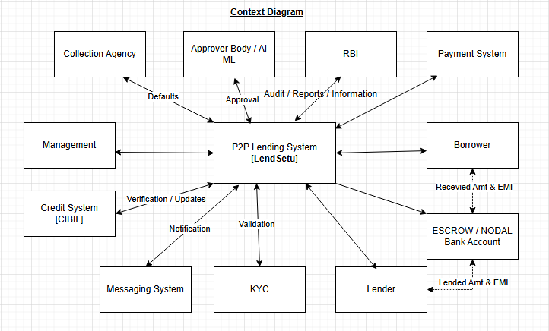

Level 2

Note*** Below is the proposed diagram for the time being. Possible to change it later on

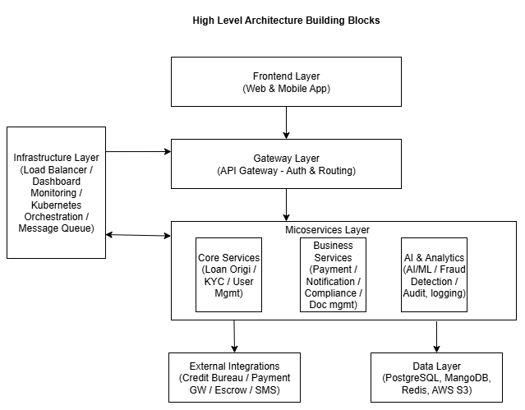

5.2.1 White Box

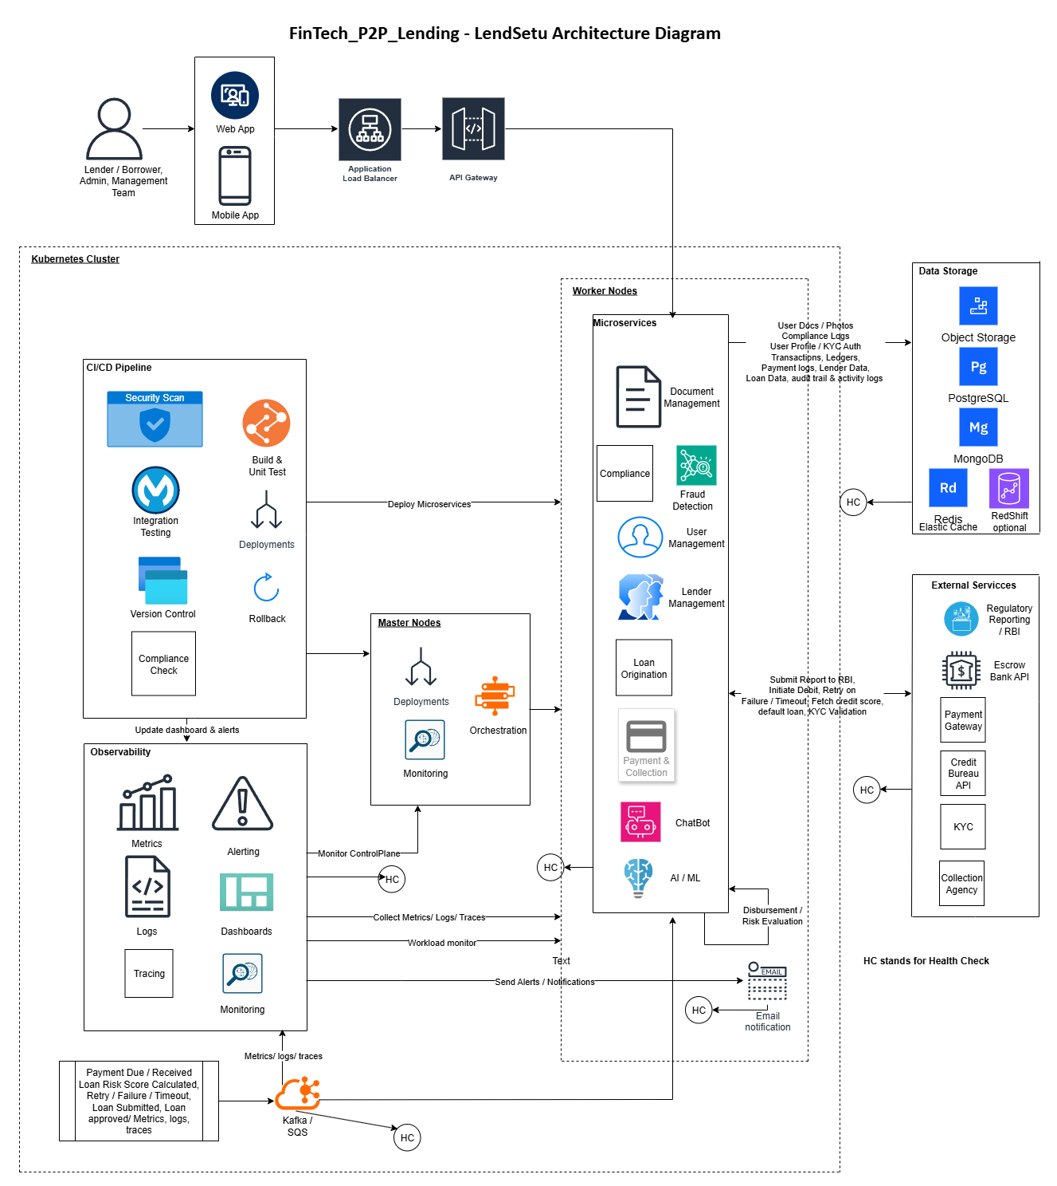

Kubernetes deployment & scaling (as shown below) can be summarized through these three core functions: -
- Automated Orchestration: Kubernetes acts as the "brain" that manages containerized microservices (like KYC, Payments, and AI scoring). It works with CI/CD pipelines to automatically build, test, and deploy new updates with zero downtime using rolling updates.
- Dynamic Scalability: The system uses Horizontal Pod Autoscaling (HPA) to automatically spin up or down service instances based on real-time demand, such as spikes in loan applications or EMI processing.
- High Availability & Compliance: To meet RBI regulations, the cluster is spread across multiple Availability Zones (AZs) within India. This ensures "self-healing" and automated failover, meaning the platform remains operational even if a specific server or datacenter zone fails.
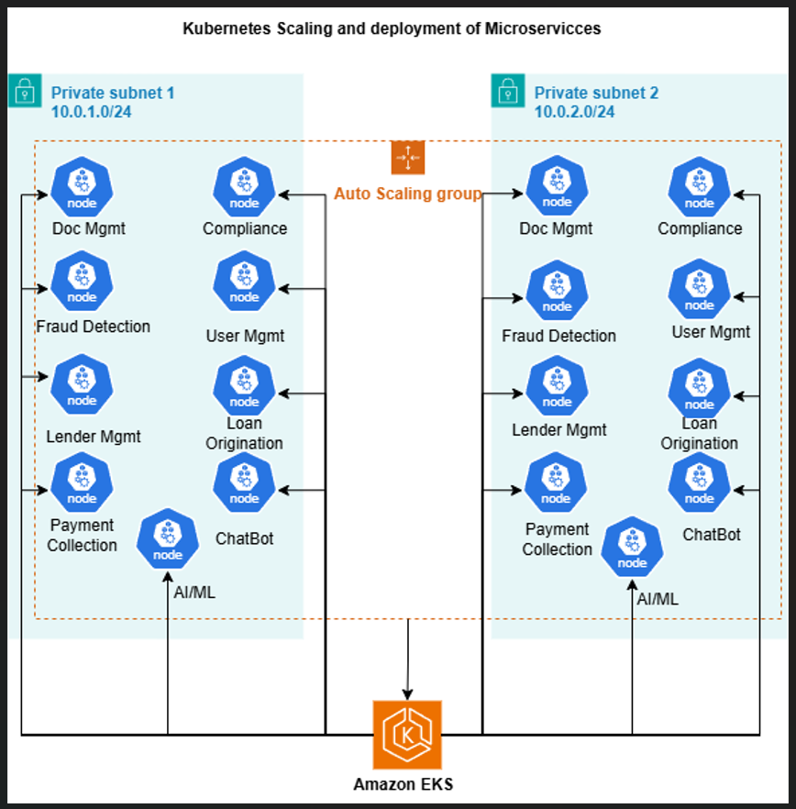

Runtime View

- Sequence Diagram – Loan Request & Approval Flow
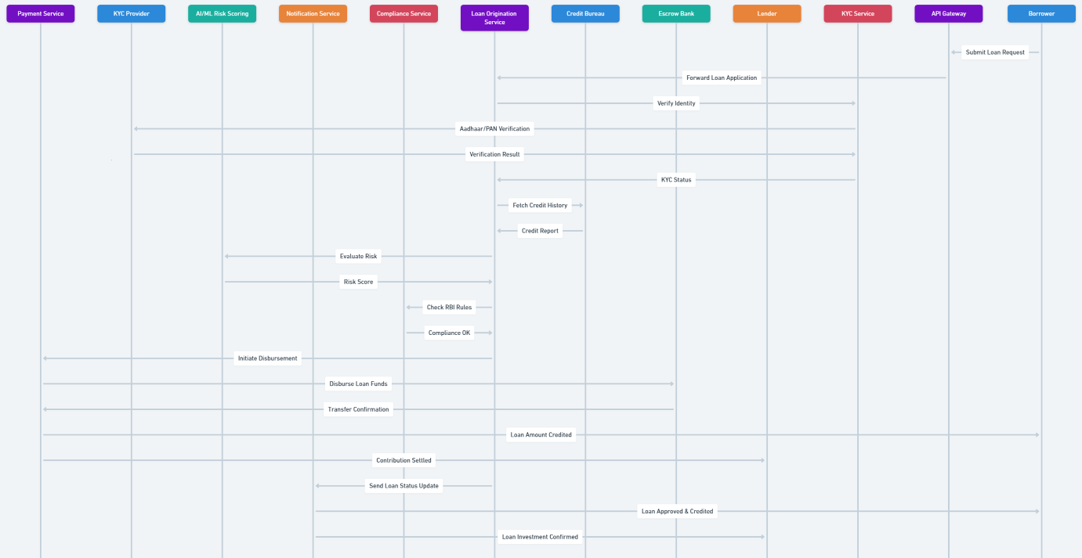

- Sequence Diagram – Loan Repayment Flow
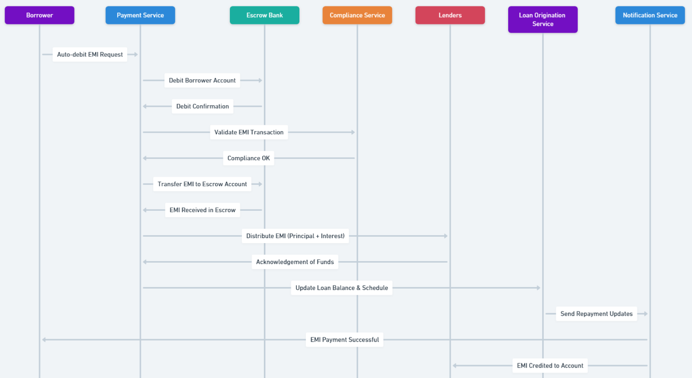

- Sequence Diagram – Failed EMI Repayment
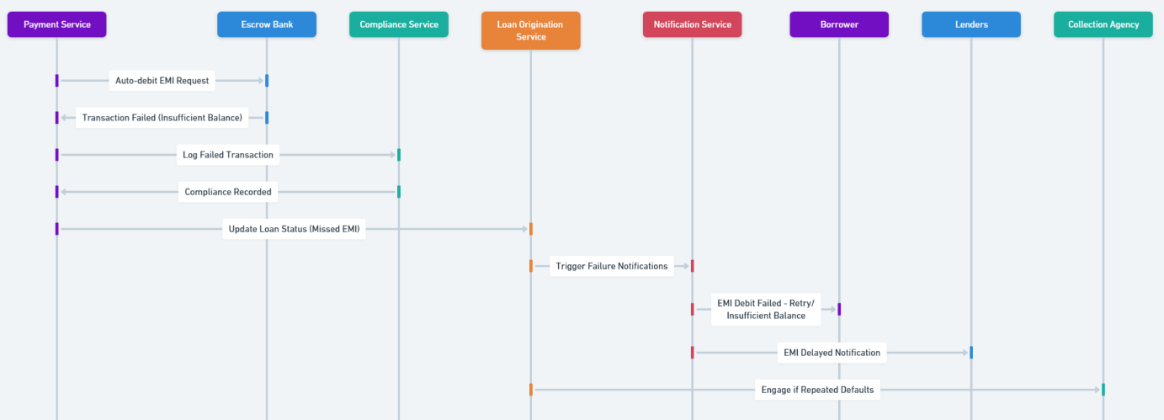
- Data Flow for Credit Scoring

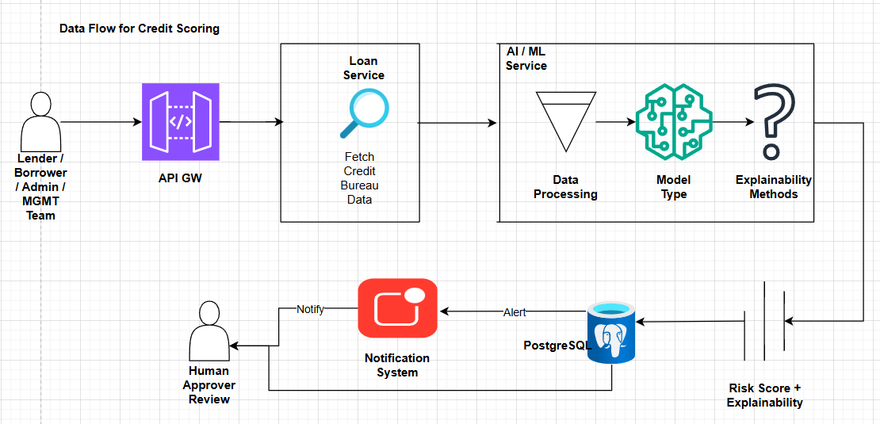

Real time Fraud Detection Pipeline (you can zoom enclosed file for more clarity)
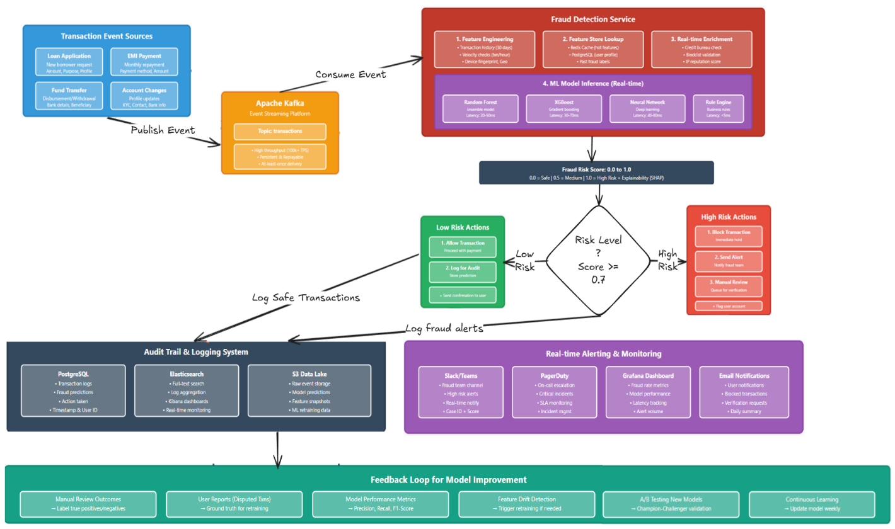

- ERD
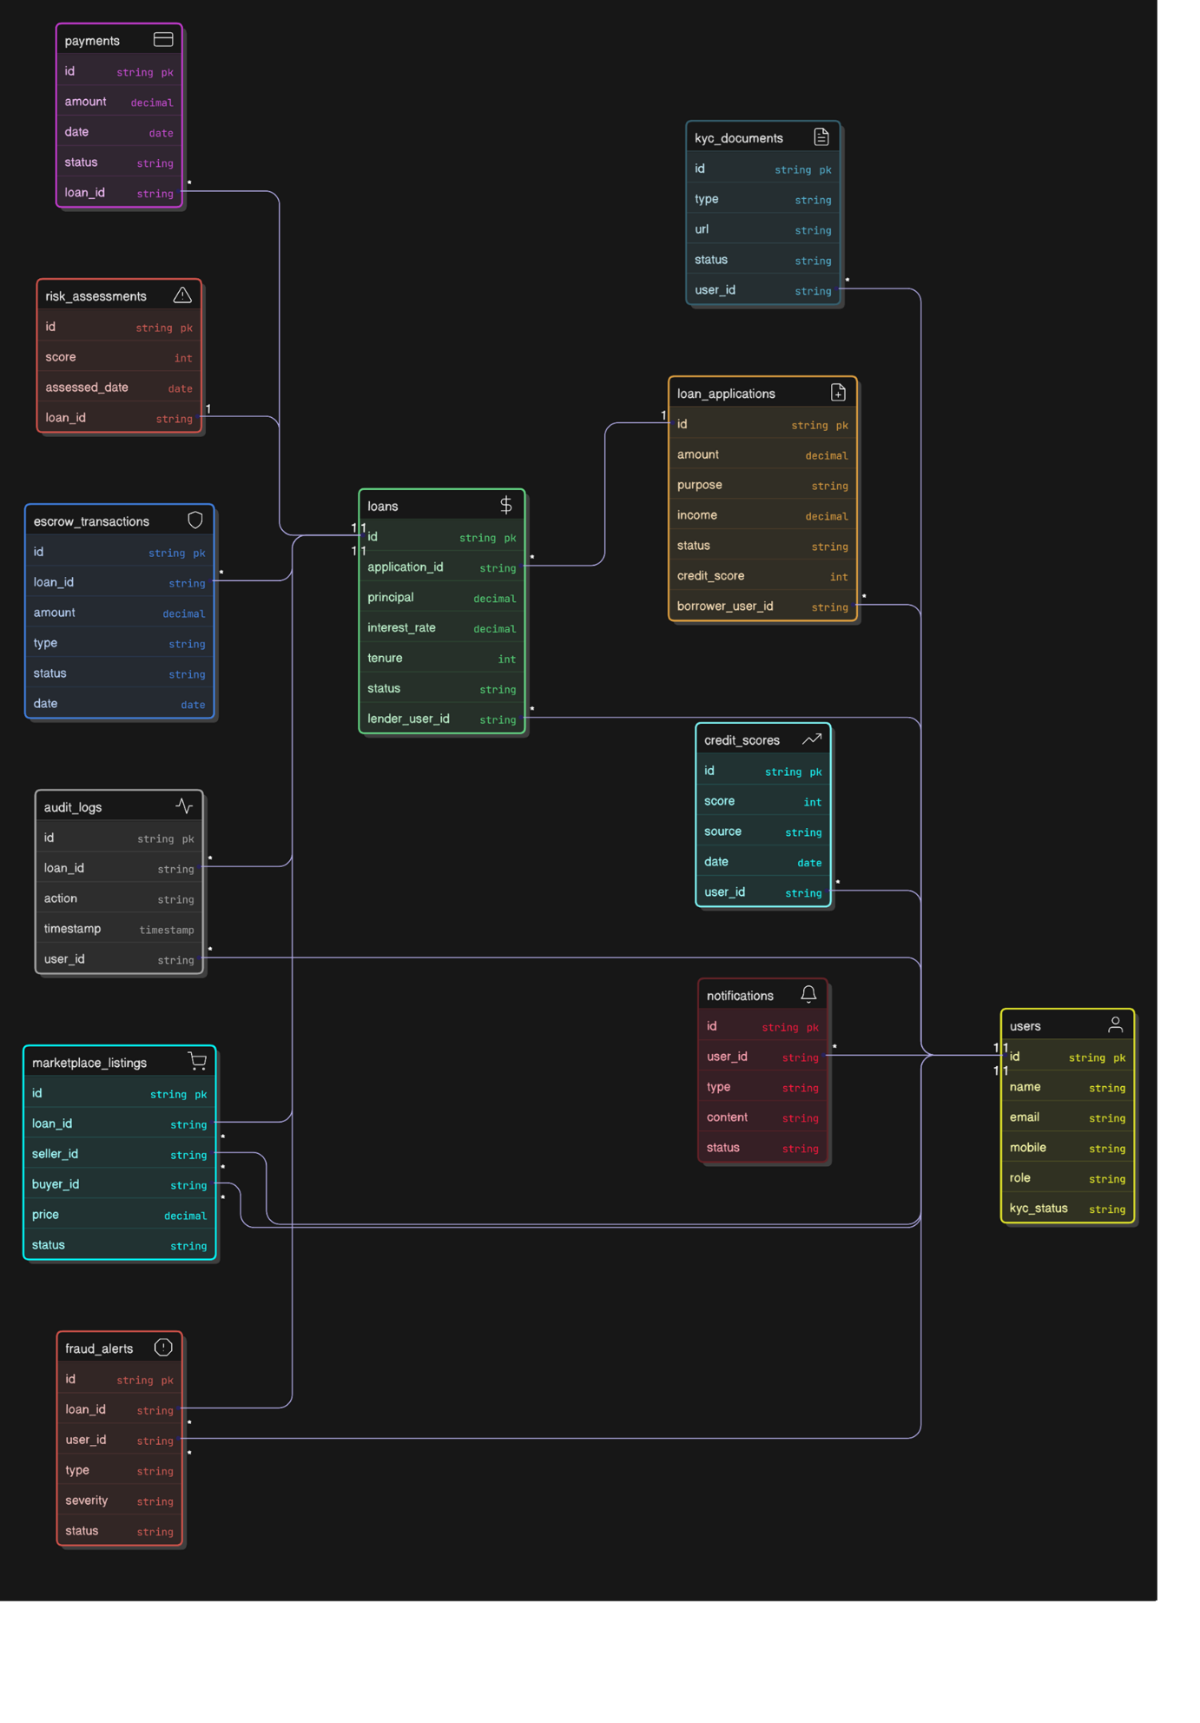

Deployment View

Architecture diagram mentioned under section 5.2 above, is self-explanatory that CI/CD pipeline deploy each microservice components through Kubernetes Orchestration. The process is common for Development, Staging and Production Servers except for production where you need to provide approved change request. Enclosing below sequence diagram for CI/CD pipeline deployment for reference.

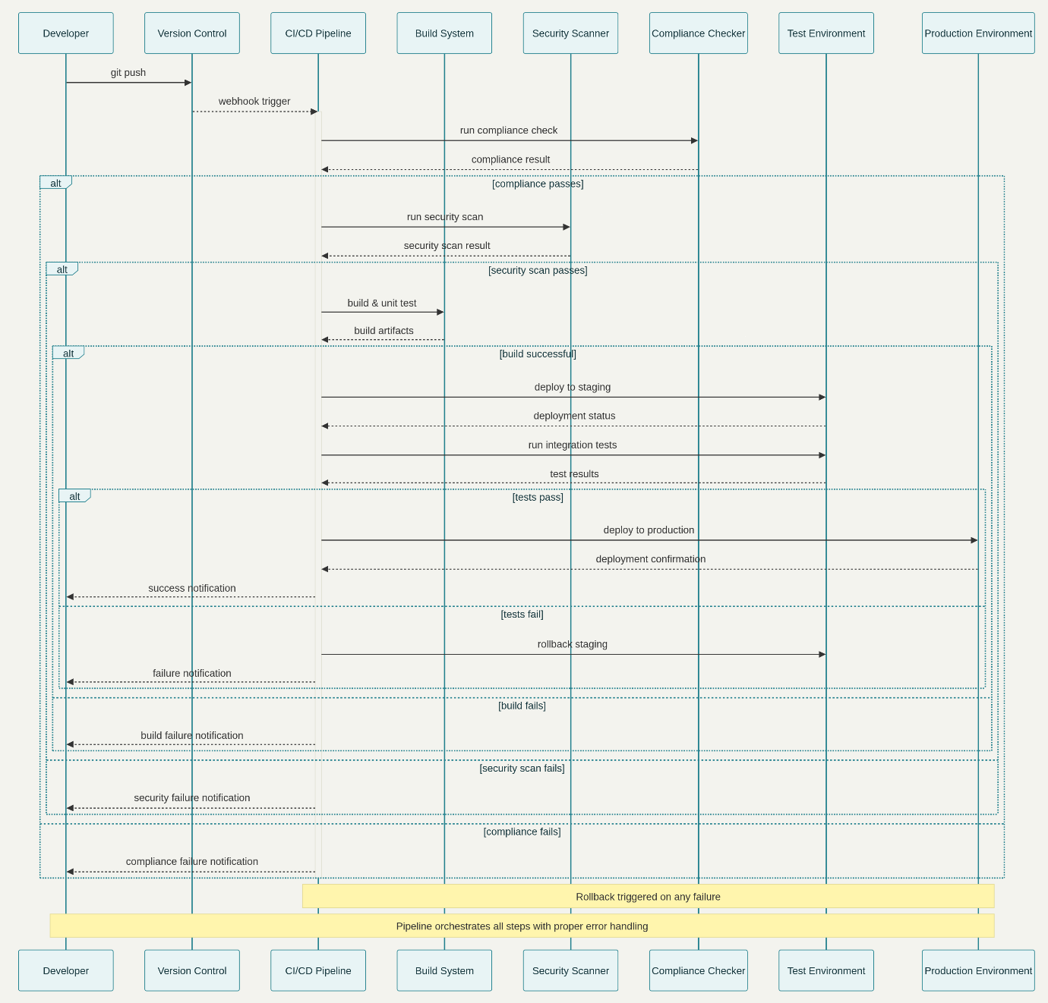

Infrastructure Level 1
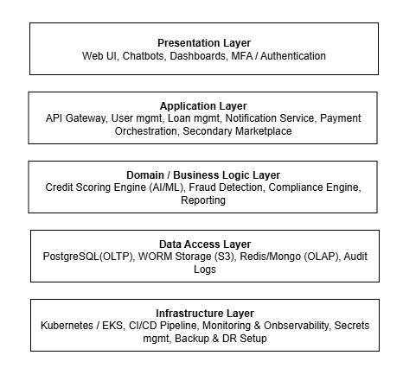
The P2P lending LendSetu platform is deployed on a cloud service provider within an Indian datacentre to meet regulatory data residency requirements. Infrastructure spans multiple Availability Zones (AZs) within this region to ensure high availability, fault tolerance, and disaster recovery. The platform is divided into separate environments for development, testing, and production, each isolated through networking (VPC/subnets) and access controls.
At its core, the production environment consists of:
  - A managed Kubernetes cluster orchestrating microservices for all business functions (user management, loan services, KYC, payments, risk scoring, compliance, fraud detection, and notifications).
  - A cloud load balancer and ingress controllers that serve as secure entry points, routing both web/mobile and API traffic to backend services.
  - Managed relational (PostgreSQL) and document-oriented (MongoDB) databases for respective ACID and flexible data needs.
  - Redis as an in-memory data store for caching and acceleration of frequent queries.
  - S3-compatible object storage for secure and scalable handling of large, unstructured data such as KYC documents and digital agreements.
  - A continuous integration/continuous delivery (CI/CD) pipeline (e.g., GitHub Actions, Jenkins) running in a secure segment, responsible for automated building, testing, and deployment of new software versions.
  - Monitoring (Prometheus, Grafana) and centralized logging (ELK Stack) systems deployed as part of the Kubernetes cluster for full-stack observability, security event detection, and regulatory audit trail maintenance.
  - Encrypted external interfaces (including VPN, dedicated links, or secure APIs) to credit bureaus, KYC service providers, payment gateways, and bank escrow services.
Physical and network connections are designed for redundancy, with each service deployed across multiple nodes and zones. This multi-AZ design ensures that a single hardware, node, or zone failure will not disrupt the entire application

Motivation for Deployment Structure
This infrastructure is designed to deliver:
- High availability and resilience, so the platform remains operational during unplanned failures, maintenance, or regional outages.
- Scalability to handle cyclical demand (such as festival loan spikes) and long-term growth, leveraging dynamic scaling at both compute (Kubernetes node pools) and database layers.
- Strong compliance and regulatory fit by keeping all sensitive and regulated data within legally mandated geographic boundaries, implementing encryption at rest and in transit, and maintaining clear audit trails.
- Rapid deployment and recovery using automation for CI/CD, backups, monitoring, and failover mechanisms.

Quality and Performance Features
- Automated backups and multi-zone replication enable robust disaster recovery and fast restoration in case of incidents.
- Low network latency is ensured by localizing data and compute in the Indian region, benefitting both user experience and regulatory compliance.
- Comprehensive monitoring and logging support proactive system health management, alerting, and easy forensic investigation.
- Elastic scalability is achieved through Kubernetes orchestration and managed databases that grow with real-time demand.
- Security-by-design, with isolation of environments, strong RBAC, encryption, regular security scans, and dedicated CI/CD segments to prevent privilege escalation or code pollution.

Mapping of Software Artifacts to Infrastructure
- Kubernetes cluster hosts all microservice containers, each responsible for different business capabilities as described in the architecture building blocks.
- Managed PostgreSQL: All critical business data (users, loans, transactions, repayments, KYC status) stored in a transactional, ACID-compliant RDBMS.
- Managed MongoDB: Used for application logs, audit trails, notifications, and fraud alerts, allowing fast read/write and schema flexibility.
- Redis: Provides caching for sessions, tokens, and frequently accessed computed data.
- S3 or Equivalent Object Storage: Stores KYC-related documents and digital agreements with encryption and fine-grained access controls.
- Load balancer: Expose secure, rate-limited REST APIs to clients (web/mobile), enforcing HTTPS and routing based on API versioning or path.
- Monitoring and Logging Stack: Collects structured and unstructured logs, metrics, and system traces from all microservices and databases.
- CI/CD Pipeline agents: Operate in an isolated network segment but are connected to both source repositories and the Kubernetes API for automated, policy-driven deployment.

Crosscutting Concepts
These "Cross-cutting Concepts" are the vital, non-functional requirements that determine whether a financial platform is reliable, compliant, and easy to maintain.
1. Security
Security is non-negotiable for a financial platform. We integrate multiple layers of defines to protect user data and financial assets.
- End-to-End Encryption (E2EE): All data moving between the user's browser, the API Gateway, and the microservices is protected by TLS/SSL encryption (HTTPS). Additionally, all sensitive data stored in the database is encrypted at rest using AES-256, ensuring that even if a server is compromised, the data remains unreadable.
- Role-Based Access Control (RBAC): Every user, whether a borrower, a lender, or an internal administrator, is assigned specific roles. Access to any resource or API endpoint is strictly controlled based on that role (e.g., a borrower cannot view a lender's profile).
- JWT/OAuth2 (Authentication): We use JSON Web Tokens (JWT) as accepted for stateless and scalable authentication. Once a user logs in, they get a cryptographically signed token that proves their identity. The API Gateway validates this token instantly without hitting the database, making the platform fast and scalable.
- Periodic Testing (Penetration Testing): We don't just secure the platform once; we actively seek out vulnerabilities. Independent security firms will perform regular penetration tests to simulate real-world attacks, ensuring our defences remain robust against evolving threats.
- Automated Anomaly Detection: Deploy AI/NLP to monitor logs, transactions, and metrics (via Splunk, ELK, etc.). Models flag deviations from normal behaviour for rapid incident containment and reduced manual investigation.
- AI-driven IAM Reinforcement: AI detects abnormal login behaviour and credential misuse by analysing user baselines (time, location, device). Deviations (e.g., new geography login, rapid API key rotation) trigger a "possible compromise" flag.
2. DevOps
DevOps is about automating everything to achieve fast, reliable, and frequent deployments (Agile and DevSecOps).
- CI/CD Pipelines (Continuous Integration / Continuous Delivery): Our workflow ensures that every code change triggers an automated process. Code is built, tested, scanned for security flaws (DevSecOps), and packaged into Docker containers automatically.
- Helm Charts: Since we use Kubernetes, Helm charts are used to package and manage all our microservices. A single Helm command can deploy, upgrade, or rollback an entire service, standardizing our deployment process.
- Automated Rollback: If any stage of the deployment process fails (e.g., a service fails its automated health check after deployment), the system automatically reverts to the last known stable version of the application.
- Blue-Green Deployment: We deploy a new version (Green) alongside the existing production version (Blue). Once Green is verified to be fully healthy, the load balancer instantly switches all traffic to Green. This eliminates downtime and makes the switch instantaneous.
3. Auditability
As a financial and regulated entity, every action taken on the platform must be traceable for compliance, investigation, and dispute resolution.
- Immutable Logging: All system actions, user interactions, and transaction status changes are recorded in centralized, tamper-proof logs. Once a log entry is created, it cannot be deleted or altered.
- Retention Policies: Logs and audit trails are kept for a specific, regulatory-mandated period (e.g., 7 years), ensuring we can retrieve any historical record required by the RBI.
- RBI-Compliant Records: The audit logs are structured to capture key information needed for financial compliance, such as transaction IDs, timestamps, user IDs, and the exact API parameters used.
- Forensic Tracking: This capability allows internal security teams to reconstruct the sequence of events leading up to any incident, whether it's a security breach or a customer dispute.
4. Performance
High performance is critical for user experience and system stability, achieved by minimizing database reliance and maximizing service responsiveness.
- Caching (Redis): We use Redis (ElastiCache) as a high-speed, distributed cache. This allows us to serve frequently accessed but non-critical data (like general loan terms or popular lender profiles) from memory instead of hitting the database repeatedly.
- Scalable Messaging (Kafka): For communication that doesn't need an immediate response (like updating a user's credit score in the background or notifying other services of a successful payment), we use Kafka. This event streaming platform decouples services and allows them to process massive volumes of events asynchronously without slowing down the primary transaction flow.
- Horizontal Scaling: All our microservices are stateless (they don't store session data). This allows us to add or remove service instances instantly based on demand, enabling massive scale during peak load.
5. Testing
Automated testing is the backbone of our quality assurance and deployment speed.
- Automated Unit Testing: Developers write tests to verify that the smallest piece of logic (a function or method) works exactly as intended. This is fast and runs with every code commit.
- Automated Integration Testing: These tests verify that multiple components, such as two microservices or a service and its database, work correctly together.
- Acceptance Testing (or E2E Testing): These tests simulate real user scenarios (e.g., "A borrower registers, applies for a loan, and is approved"). They ensure the entire system works correctly from the frontend to the backend, giving us confidence before deployment.
6. Document Management
Handling sensitive customer documents (KYC, income proof) requires robust security and controlled access.
- Encrypted, Access-Controlled S3 Storage: All documents are uploaded and stored in a secure cloud object storage service (AWS S3), where they are encrypted at rest. Access is strictly controlled, even by internal teams.
- Pre-signed Retrieval URLs: When a service or authorized human needs to view a document, the Document Management Service does not expose the direct storage path. Instead, it generates a unique, time-limited URL. This URL expires after a few minutes, ensuring that the document cannot be accessed if the URL is intercepted or shared.
7. AI/ML
The core of our intelligent decision-making requires specific protocols to ensure the models are fair, compliant, and accurate.
- Explainability Techniques (SHAP/LIME): As detailed in the previous ADR, we won't deploy "black box" models. We use techniques like SHAP and LIME to generate reason codes for every loan decision. This allows us to tell a user exactly why they were declined, meeting both regulatory and fairness requirements.
- Bias Detection: Before any model is deployed, it is audited to ensure it does not unfairly disadvantage specific borrower demographics (e.g., based on location or income group). If bias is detected, the model is adjusted, or human review is implemented for affected cases.
- Retraining Protocols: The world changes, and so does risk behaviour (Model Drift). We have a scheduled MLOps pipeline that automatically monitors model performance and retrains the model on the latest data on a regular cycle (e.g., monthly). This keeps our risk scoring accurate and current.
Replacing External (Credit Bureau, Fraud Detection) Systems with In-House AI
How to Transition:
1. Start by aggregating all possible internal transaction, repayment, and behaviour data. Over time, this builds a data asset rivalling external sources.
2. Use external bureau/fraud system outputs as initial training labels (teacher-student learning). As your dataset grows, rely increasingly on internal data.
3. Run both internal AI and external systems in parallel. Compare outcomes for a set period ("shadow" mode). Gradually decrease dependency on external sources as internal AI matches or surpasses their accuracy.
4. Demonstrate explainability, fairness, and reliability of your AI models to regulators before final decommissioning of external systems.
5. Set up auto-updating pipelines for ongoing model retraining so that as fraud patterns or credit risk profiles evolve, your models adapt without external data file.
6. Refactor integration logic so that platform services query the in-house AIML microservice for equivalent data (credit score, fraud flag, etc.).
8. Compliance: -
- Automated RBI Compliance Checks: AI uses rule-based engines (Drools) and OCR/NLP on KYC documents to verify that loan limits, borrower exposure, and document formats meet RBI guidelines. This automates audit preparation and provides faster KYC/AML checks with fewer manual errors.
- AI for Continuous Audit: AI uses ML on immutable logs to instantly flag data tampering or regulatory breaches, providing automated compliance validation.
9. API & Ecosystem Interfaces Design: - (You can refer ADR 18 - Communication Protocol - RESTful APIs)
The "API & Ecosystem Interfaces Design" in the LendSetu P2P Lending Architecture revolves around the use of RESTful APIs to connect both internal microservices and external partners, ensuring secure, scalable, and compliant operations across the platform. The system is fundamentally microservices-based, allowing independent deployment and scaling of functional components such as user management, KYC, loan origination, payments, compliance, and fraud detection.
API Gateway and Microservice Design
- All interactions—whether between the frontend and backend or from external systems—are routed through an API Gateway. This gateway handles authentication (using OAuth2 and JWT), rate limiting, and request routing to respective backend services. It enforces secure HTTPS/TLS for all communications.
- Each microservice (like User, Loan, Payments, AIML Risk Scoring, Compliance, Notifications) exposes standardized RESTful APIs, following clear HTTP verbs (GET, POST, PUT, DELETE), and stateless request/response cycles in JSON format.​
- Internal microservices use synchronous RESTful calls for real-time operations and asynchronous event-driven messaging (Kafka, SQS) for decoupled workflows such as notifications, credit scoring updates, or transactional event processing.
External Ecosystem Integrations
- The architecture natively supports secure integrations with external parties:
  - Credit bureaus (CIBIL, Experian, Equifax) for real-time credit checks via API.
  - Payment gateways (Razorpay, PayU, Paytm) for fund disbursements, EMI collections, and settlements—enforcing RBI escrow requirements.​
  - KYC services (Aadhaar, PAN) and bank APIs for compliance, identity checks, and escrow automation.
  - Messaging services for notifications (SMS, Email via AWS SNS/SES).
  - Collections agencies, other financial partners, all through securely authenticated and documented endpoints.
API Documentation and Governance
- All APIs are documented using standards like OpenAPI/Swagger, auto-generated from code annotations.
- Versioning follows semantic principles; breaking changes prompt deprecation notices. Internal and public-facing APIs are catalogued on a developer portal (e.g., Backstage.io).
- Security is reinforced by role-based access (RBAC), comprehensive encryption, and regular penetration testing
Design Benefits and Challenges
- RESTful, stateless APIs make the platform modular and horizontally scalable. Third-party partners can integrate easily, and new microservices can be added or updated independently.
- However, strict versioning, documentation, and governance are required to prevent integration errors, scaling challenges, and ensure regulatory compliance.
This approach delivers a future-proof, cloud-agnostic, and RBI-compliant lending platform where robust APIs and secure ecosystem interfaces are central to the business and technical strategy

Architecture Decisions
01: Microservices over Monolith Architecture
Status: Accepted
Context: The system must handle borrower onboarding, KYC, loan approvals, EMI payments, credit bureau integration, and AI/ML risk scoring. These are independent domains with different scaling needs. A monolithic approach might work initially but can cause scalability bottlenecks as the platform grows, especially when services are tightly coupled and require simultaneous scaling. Additionally, the ability to quickly release new features and implement regulatory changes is essential for the platform’s success. A microservices-based architecture is proposed to handle these concerns.
Decision: We will implement a microservices architecture for the P2P lending platform. This architecture will decompose the system into small, independent services, each focused on a specific business capability, such as loan origination, user management, payments, fraud detection, and others.
Consequences:
Pros:
    - Scalability: Each microservice can scale independently based on demand (e.g., payment service might require more resources during EMI cycles).
    - Faster development and deployment: Teams can work independently on different services without waiting for others to finish.
    - Flexibility in technology: Microservices allow us to use different technologies that best fit the requirements of each service (e.g., Python for AI/ML, Node.js for API Gateway).
    - Resilience: Failure in one microservice does not bring down the entire system, ensuring better fault tolerance.
    - Improved agility: Easier to adapt to regulatory changes (e.g., adding or modifying compliance rules).
Cons:
    - Increased operational complexity: Multiple services to monitor, deploy, and maintain. Requires effective DevOps, CI/CD, and logging/monitoring strategies.
    - Network overhead: Inter-service communication adds latency compared to monolithic applications, especially if synchronous calls are required.
    - Distributed debugging and testing: Troubleshooting issues across services can be complex and time-consuming.
- Data consistency: Ensuring eventual consistency across multiple services can lead to challenges, particularly when updating shared data.
Alternatives Considered:
- Monolith Architecture: A single application that handles all platform functionality (e.g., borrower onboarding, KYC, loan processing) in one large, interconnected system.
- SOA: An approach where the platform is split into large services (e.g., payment service, loan service), each with its own database, but still tightly coupled compared to microservices.
02: Monitoring & Alerting - Observability Stack
Status: Accepted
Context: In a distributed system, it is challenging to troubleshoot issues and understand the system's behaviour without a holistic view of its health. We need to be able to proactively detect problems before they impact users.
Decision: A full observability stack will be implemented, combining Prometheus (for metrics and alerting), the ELK Stack (for centralized logging), and a distributed tracing tool (e.g., Jaeger or Zipkin).
Consequences:
Pros:
  - Proactive issue resolution: Monitoring metrics will help identify issues before they affect users (e.g., degraded performance, increased error rates).
  - Better operational visibility: We’ll gain insights into resource usage, latency, and failure points, improving both system performance and debugging.
  - Regulatory compliance: Ensures we have detailed, auditable logs (required by RBI).
- Alerting & Automation: Real-time alerts can trigger automated remediation actions to ensure uptime, reducing manual intervention
Cons:
  - Complex setup: Integrating multiple tools (Prometheus, Grafana, ELK, Jaeger) will require additional effort and expertise.
  - Cost overhead: Running observability tools, especially at scale, can lead to significant storage and compute costs for metrics, logs, and traces.
- Overhead for scaling: Continuous metrics gathering, log processing, and distributed tracing can consume resources (e.g., storage, CPU) that need to be properly managed to avoid performance degradation
Alternatives Considered:
- Basic Server Monitoring
  - Description: Use cloud-native monitoring tools (like AWS CloudWatch) for basic metrics (CPU, memory usage) and logs.
- Cloud-native Full Observability
  - Description: Use an external SaaS-based observability tool like New Relic or Datadog. These tools offer out-of-the-box solutions for metrics, logs, and tracing.
- Log Aggregation-only Solution
  - Description: Use Fluentd for log aggregation and store them in ElasticSearch without using Prometheus or Grafana for metrics.
03: Data Residency - In-Country Hosting
Status: Accepted
Context: The Reserve Bank of India (RBI) mandates that all data related to financial transactions and user information must be stored on servers located within India. This is a critical, non-negotiable constraint. The P2P lending platform must adhere to these regulations to operate legally and avoid penalties. The platform will also handle highly sensitive user data (borrower/lender profiles, loan transactions, KYC documents), making compliance with data residency a critical concern.
Decision: The platform will be deployed exclusively on a public cloud provider's region located within India. All databases and document storage will be physically hosted in Indian datacentres. This decision ensures that all platform data stays within Indian borders and complies with RBI's data residency guidelines.
Consequences:
Pros:
    - RBI Compliance: Full compliance with RBI data residency regulations ensures legal operation of the platform in India.
    - Data Sovereignty: Data will be governed by Indian laws, providing local data protection and privacy.
    - Improved Performance: Reduced latency for Indian users since all services and data are hosted locally.
    - Enhanced Trust: Users may feel more secure knowing that their data is hosted within India.
Cons:
    - Vendor Lock-in: Hosting exclusively on AWS India may result in dependency on a single cloud provider, reducing flexibility if migration is required in the future.
    - Cost Overheads: Cloud services in India could have a different cost structure, possibly higher than regions like North Virginia or Singapore.
- Limited Global Reach: While we gain compliance with Indian regulations, expanding beyond India could require data replication or additional considerations for cross-border data flow
Alternatives Considered:
- Global Cloud Deployment with Data Replication in India
  - Description: Data stored globally (e.g., US or Singapore) with replication to Indian datacentres for compliance.
- On-Premise Hosting in India
  - Description: Set up an on-premise datacentre in India to host all data locally.
- Multi-Cloud
  - Description: Use both AWS and other cloud providers for hosting across multiple regions.
04: Data Management - Asynchronous Communication
Status: Accepted
Context: In a microservices architecture, services need to communicate. Relying on direct, synchronous calls can lead to tight coupling, where one service becomes dependent on the immediate availability of another. This creates a risk of cascading failures and is detrimental to our high-availability goal.
Decision: Services will primarily communicate asynchronously using a message queue or event bus (e.g., Kafka). When a key event occurs, the originating service will publish a message that other services can consume at their own pace. This will allow for loose coupling and better fault tolerance, as services don’t depend on each other’s immediate response to continue their operations
Consequences:
Pros:
  - Resilience & Fault Tolerance: Services can operate independently. If one service is down, the event remains in Kafka and can be processed later.
  - Scalability: The system can easily scale by adding consumers to process events when traffic increases.
  - Improved Performance: By decoupling the services, requests don’t need to wait for responses from other services, leading to faster user interactions (asynchronous processing).
  - Event Replay: Since Kafka stores events, we can replay events for debugging, auditing, or system recovery.
- Non-blocking operations: Services don’t block other services from processing requests while waiting for responses, reducing latency
Cons:
  - Eventual Consistency: The system will become eventually consistent, meaning that the data across services may not be synchronized at all times, which can lead to temporary discrepancies.
  - Complexity in Error Handling: In case of failure (e.g., processing an event fails), managing retries, dead-letter queues, and ensuring data consistency between services becomes more complex.
  - Operational Overhead: Kafka and event-driven systems require management and monitoring tools to ensure message delivery and retention, which adds operational overhead.
    - Increased Latency: While the system will be more resilient, there is a slight increase in latency because services no longer get responses immediately after an event is published
Alternatives Considered:
- Synchronous Communication (REST API)
Description: Services would directly call each other via REST API requests (e.g., Loan Service calls Payment Service to initiate an EMI payment).
- Queue-based Communication (e.g., AWS SQS)
Description: Use a message queue service like SQS for async communication between services. The services will send messages to the queue, and consumers will process them independently.
- RabbitMQ
Description: A message broker like RabbitMQ could also be used for asynchronous messaging between services, supporting message queuing and event-based delivery.
05: Document Storage - Object Storage
Status: Accepted
Context:
The P2P lending platform needs to store sensitive documents (e.g., KYC documents, loan agreements, borrower identification) for compliance and operational purposes. These documents can be large (e.g., PDF, image files) and require high durability, scalability, and secure access controls.
Traditional relational databases are not suitable for storing large binary files, and maintaining them in a file system or on-premise infrastructure can be cumbersome and resource-intensive. Given the scale and the need for easy access, we need a cloud-based storage solution that is both cost-effective and secure.
Decision:
We will use cloud-based object storage services like AWS S3 (Simple Storage Service) or Google Cloud Storage (GCS) to store user documents (KYC, PAN, Aadhaar, loan contracts) in India-based datacentres to comply with RBI’s data residency regulations.
The documents will be stored in object storage buckets, with pre-signed URLs provided to authorized users for temporary access. This solution ensures both scalability (handling high volumes of large files) and security (access control via IAM roles, encryption, etc.).
Consequences:
Pros:
    - Scalable & Cost-effective: Object storage solutions automatically scale to accommodate an increasing volume of documents, and you only pay for the storage you use.
    - High Durability & Availability: Services like AWS S3 offer 11 9's durability, ensuring data is not lost and remains available.
    - Built-in Security Features:
      - Encryption at rest and in transit ensures data privacy.
      - IAM roles and ACLs control access to documents based on user permissions.
    - Compliance-ready: Object storage is widely used in compliance-heavy industries and offers features like versioning and WORM (Write Once, Read Many) storage for audit trails.
    - No Infrastructure Overhead: No need for self-hosted storage solutions, reducing hardware and management costs.
Cons:
    - Access Control Complexity: While object storage is secure, proper access controls (e.g., through pre-signed URLs) must be set up to avoid unauthorized access.
    - Cost Overhead for Retrieval: While storing files is cheap, frequent access or retrieval can incur higher costs, especially for large files.
    - Dependency on Cloud Provider: The platform becomes dependent on the selected cloud provider (e.g., AWS, GCP), which can lead to vendor lock-in.
    - Data Egress Costs: If documents are frequently accessed from outside the cloud or transferred across regions, egress (data transfer out) costs may accumulate.
Alternatives Considered:
- On-Premise File System
Description: Storing files in a traditional on-premise file server or network-attached storage (NAS) solution.
- Relational Database (e.g., PostgreSQL or MySQL)
Description: Storing documents as BLOBs (binary large objects) directly in a relational database.
- Hybrid Cloud (Object Storage + File Servers)
Description: Using cloud-based object storage for large files while maintaining an on-premise file server for internal document management.
06: Technology Stack - Backend
Status: Proposed
Context:
The P2P lending platform will support various business functionalities such as loan origination, user management, payments, KYC, and credit scoring. Each of these services has different performance characteristics and requirements. For example, the AI/ML-based credit scoring service is CPU-intensive, while payment processing services are I/O-bound and need to handle large volumes of transactions.
Using a single language or framework for the entire backend might result in inefficient performance, as some services might be better suited to one language, while others may require different optimizations. Additionally, the platform needs to scale efficiently, so selecting the right technology stack for each service is critical to achieving both performance optimization and developer flexibility.
Decision:
The backend will adopt a polyglot architecture, using different programming languages and frameworks for different services based on their specific requirements:
- Python (with frameworks like FastAPI or Flask) will be used for CPU-bound services, including AI/ML services, such as credit scoring, fraud detection, etc.
- Node.js will be used for I/O-bound services, such as the API Gateway and real-time user notifications.
- Java (Spring Boot) could be used for high-throughput transactional services (like loan origination and payment processing), where performance and reliability are key.
Consequences:
Pros:
    - Optimized performance per service: Each service can be built using the best-suited language for its performance characteristics (e.g., Python for AI/ML, Node.js for async I/O).
    - Improved developer productivity: Teams can use their expertise in different languages to build services faster and more effectively.
    - Scalability: Each service can scale independently based on the workload. For example, the AI/ML service might scale up only when large volumes of data need processing, while the API Gateway can handle high I/O loads more effectively with Node.js.
    - Flexibility in choosing the best tool for the job: We are not restricted to a single technology stack, enabling us to make the right decisions for each microservice.
Cons:
    - Increased operational complexity: Managing different languages, tools, and frameworks can increase the operational burden for the development and DevOps teams, requiring more specialized expertise.
    - Multiple build tools and environments: The development pipeline will need to accommodate different language ecosystems, which increases build and deployment complexity.
    - Higher learning curve: Developers may need to learn and adapt to multiple programming languages and frameworks, which could slow down initial development.
    - Integration complexity: Different services will need to communicate using standardized APIs (e.g., REST or gRPC), which may add complexity when ensuring smooth interaction between microservices.
Alternatives Considered:
- Monolithic Stack (Single Language)
  - Description: Use a single language (e.g., Java or Node.js) for the entire backend, handling all services (transactional, I/O-bound, AI/ML) with one technology stack.
- Service-Oriented Architecture (SOA) with Uniform Stack
  - Description: Use a common technology stack for all services, such as Java Spring Boot or Node.js, while breaking down services into domains like loan origination, payments, and credit scoring.
- Microservices with Dockerized Monolithic Stack
  - Description: Use Docker to containerize a monolithic application (e.g., a single app built with Java/Spring or Node.js) but run it as microservices for each business functionality.
07: Data Storage Persistence
Status: Accepted
Context:
The P2P lending platform needs to store and retrieve data efficiently. The platform will handle large amounts of data, including user profiles, loan applications, KYC documents, transaction histories, and loan repayment schedules. These data have different characteristics (e.g., highly structured for user data and loan details, semi-structured for logs, and unstructured for documents).
Selecting the right storage approach is crucial because:
- Real-time transactional data (e.g., loan origination and EMI repayments) needs ACID properties (Atomicity, Consistency, Isolation, Durability).
- High-volume, low-latency data processing is needed for audit logs, user activity, and credit scoring.
- Document storage (e.g., KYC documents, loan agreements) needs to be cost-efficient, scalable, and secure.
Given the multi-domain needs, using a single database type may not provide the required performance for all scenarios. A polyglot persistence approach is needed, leveraging both relational and NoSQL technologies for the different data types.
Decision:
We will use a polyglot persistence approach:
- PostgreSQL will be used for transactional data (e.g., loan origination, payment tracking), as it supports ACID compliance and strong referential integrity.
- MongoDB (or similar NoSQL databases) will be used for semi-structured data (e.g., user activity logs, application metadata) and schema flexibility.
- Amazon S3 (or Google Cloud Storage) will be used for storing unstructured data such as KYC documents, loan agreements, and other large binary files, as object storage provides scalability and durability.
- Redis will be used for in-memory caching of frequently accessed data (e.g., loan status checks, user information), reducing load on databases and improving response times
Consequences:
Pros:
    - Optimized for different workloads: By using the right storage solution for each type of data, we can optimize performance, reliability, and cost.
    - Scalability: NoSQL solutions like MongoDB and Redis allow for horizontal scaling, supporting future growth in user data and transaction volume.
    - Efficient handling of large files: S3 and similar object storage solutions allow for easy scalability and cost-effective storage for large files like documents.
    - Increased fault tolerance: Using separate databases and services ensures that failure in one part of the system doesn't impact the entire platform.
    - Security & Compliance: PostgreSQL offers strong data security features like encryption at rest, and S3 provides managed services for secure storage of sensitive documents (encrypted and controlled access).
Cons:
    - Increased complexity: Managing different database systems (SQL, NoSQL, caching, object storage) can increase operational complexity, especially in terms of backup, replication, and monitoring.
    - Integration overhead: Data consistency between PostgreSQL and MongoDB (or other databases) can be challenging, especially when synchronizing data or integrating reporting across databases.
    - Data duplication: There may be some level of data duplication across systems (e.g., user information in PostgreSQL and Redis) for performance reasons, increasing maintenance overhead.
Alternatives Considered:
- Single Database (PostgreSQL or MySQL only)
Description: Use a single relational database (PostgreSQL or MySQL) for all types of data (transactional, semi-structured, and unstructured).
- NoSQL Only (e.g., MongoDB or Cassandra)
Description: Use only NoSQL databases (e.g., MongoDB, Cassandra) for all data types.
- Full Object Storage (e.g., AWS S3 or Google Cloud Storage)
Description: Store all data in object storage (e.g., AWS S3, GCP Cloud Storage).
08: Authentication & Authorization
Status: Accepted
Context: The P2P lending platform requires secure and scalable authentication and authorization mechanisms to ensure that only authorized users can access specific resources and perform actions such as borrowing, lending, and accessing KYC documents. The platform will support multiple client types, including web apps, mobile apps, and third-party integrations (e.g., banks, credit bureaus).
The system needs to handle stateless authentication in a distributed microservices architecture, where each service needs to validate users without relying on a central session store. This requires a solution that is scalable and secure while avoiding the performance bottlenecks of traditional session-based authentication.
JWT (JSON Web Tokens) are widely used for secure token-based authentication in modern distributed systems, and we need to ensure that this approach meets the platform's security, scalability, and regulatory compliance requirements (e.g., RBI regulations for financial services).
Decision: We will implement JWT (JSON Web Token) for stateless authentication. The system will use OAuth2 or OpenID Connect (OIDC) protocols for user authentication, and the API Gateway will validate JWTs on incoming requests to ensure that only authorized users can access resources.
JWTs will be issued by an Authentication Service upon successful login and will contain claims like user roles, permissions, and token expiration information. The token will be passed in the Authorization header for each subsequent API request. This ensures decentralized validation, reducing dependency on central session stores.
Consequences:
Pros:
    - Scalable: JWTs are stateless and do not require session storage on the server, making it easy to scale the platform horizontally. Each service can validate the JWT without needing to query a central database or session store.
    - Improved Performance: By avoiding session management, the system reduces the overhead of maintaining sessions, resulting in lower latency and faster response times.
    - Cross-platform compatibility: JWT is a widely adopted standard, enabling smooth single sign-on (SSO) across different client types (e.g., web, mobile, API services).
    - Security: JWTs support signed tokens (using algorithms like RS256) to ensure integrity and optional encryption (e.g., JWE) to protect sensitive data in the payload.
    - Decentralized Authentication: The JWT token can be validated by any microservice independently, improving fault tolerance and resilience in the distributed architecture.
    - Simplified Authorization: JWT can encode user roles and permissions directly, enabling efficient role-based access control (RBAC) without requiring complex database lookups.
Cons:
    - Token Revocation Complexity: JWTs are stateless and typically cannot be easily revoked before their expiration, making it difficult to invalidate tokens (e.g., in the case of account compromise). We need to implement a blacklist or short expiration times to mitigate this issue.
    - Token Size: JWTs can grow in size if too many claims are included, leading to larger HTTP headers and potentially higher network overhead.
    - Security Considerations: If signing keys or private keys are compromised, all JWTs can be forged. Hence, key management and rotation are critical.
    - Complexity in Security: If tokens are not properly secured (e.g., secure transport with HTTPS), they could be intercepted during transmission. Proper key management and token expiration policies must be implemented to ensure security.
Alternatives Considered:
- Session-based Authentication
Description: Traditional session-based authentication, where the server maintains session state for each user, storing session IDs in cookies or database.
- OAuth2/OIDC with SSO (Without JWT)
Description: Use OAuth2 or OpenID Connect (OIDC) for authentication with a centralized Identity Provider (IdP) (e.g., Keycloak, Auth0), but without using JWT for authorization in backend services.
- Custom Authentication Token (Non-JWT)
Description: Create a custom token system (e.g., using HMAC for signing tokens) instead of JWT.
09: AI/ML for Risk Scoring with Human Oversight
Status: Proposed
Context:
The P2P lending platform needs to evaluate the creditworthiness of borrowers to reduce the risk of loan defaults. The platform must adopt an efficient, accurate, and scalable way to assess this risk.
While traditional rule-based scoring models (e.g., FICO, custom scoring algorithms) are effective, they may lack the sophistication and flexibility needed to handle complex borrower profiles and evolving financial behaviours. Moreover, borrowers’ data, such as financial history and transactional behaviour, can be diverse and unstructured, making it challenging for rule-based systems to capture.
AI/ML-based credit risk scoring offers the potential for better prediction accuracy and adaptive learning as more data is gathered. However, due to compliance and regulatory requirements (e.g., RBI), a human-in-the-loop process is needed for transparency, explainability, and ensuring compliance with lending guidelines.
Decision:
We will use AI/ML models (such as Random Forest, XGBoost, or Neural Networks) for risk scoring based on historical borrower data, credit bureau data, transactional data, and behavioural analytics. The system will provide a predicted risk score, which will be reviewed and validated by a human approver before final approval or rejection of the loan.
- AI/ML Models: These models will be trained on historical loan data and borrower behaviour, continuously improving as new data is collected. The system will also provide explainability and interpretability (using techniques like LIME or SHAP) for transparency.
- Human Oversight: A risk management team or a human approver will validate cases flagged as high-risk or edge cases that the AI model may not fully explain or that require further judgment.
- Continuous Learning: The system will allow for feedback loops, where human-approved loans (or rejections) will improve the model over time, adapting to changing borrower behaviour.
Consequences:
Pros:
    - Improved accuracy: AI/ML models can learn complex patterns in borrower data, leading to more accurate risk predictions compared to traditional rule-based systems.
    - Scalability: As the volume of loan applications grows, AI models can efficiently assess risk at scale without requiring additional manual intervention.
    - Better decision-making: Combining AI-based predictions with human oversight helps ensure that decisions are not entirely automated, reducing the chances of incorrect or biased judgments.
    - Regulatory compliance: Human oversight ensures compliance with financial regulations and provides transparency, which is critical for meeting RBI guidelines.
    - Continuous improvement: The system will become more accurate over time as the AI model learns from feedback provided by human approvers
Cons:
    - Slower decision-making: While AI can predict risk quickly, human validation may introduce delays, especially for edge cases or high-risk loans.
    - Dependency on data quality: The accuracy of AI/ML models depends heavily on the quality and volume of data. Poor data quality or biased data could lead to inaccurate risk scores.
    - Operational complexity: Managing AI/ML models alongside human reviewers requires robust workflows and coordination, which adds complexity to the platform.
    - Model biases: If not carefully managed, AI/ML models can inherit biases present in the training data, leading to unfair or discriminatory decisions. Careful model monitoring and retraining will be required.
Alternatives Considered:
- Fully AI/ML-based Risk Scoring (No Human Oversight)
Description: Rely entirely on AI/ML models for risk scoring and loan approval without human intervention, automating the entire process.
- Fully Human-based Risk Scoring (No AI/ML)
Description: Use manual underwriting with human analysts reviewing every loan application, assessing the risk based on predefined rules or personal judgment.
- Rule-based Scoring with AI Support
Description: Use a rule-based scoring model for primary risk assessment, with AI/ML used to support and provide insights into borderline or edge cases.
10: Secondary Loan Marketplace Enablement
Status: Proposed
Context:
- In P2P lending, lenders usually lock their money for the full tenure of the borrower’s loan (e.g., 12–36 months).
- Some lenders may require liquidity before the loan matures (emergency, portfolio rebalancing).
- To improve flexibility, many P2P platforms worldwide allow secondary marketplaces, where lenders can sell their outstanding loan portions to other willing investors before the loan term ends.
- RBI has permitted such mechanisms under strict guidelines, provided transparency, borrower consent, and compliance are ensured.
- This requires careful ledger management, transaction transparency, fair pricing, and escrow compliance.
Decision:
- Implement a Secondary Loan Marketplace where lenders can list their active loans (whole or fraction) for resale.
- Borrowers continue paying EMIs as usual, but repayments are redirected to the new lender after the transfer.
- Marketplace governed by platform rules:
  - Loan eligibility check before resale.
  - Price discovery via fixed price or bidding (RBI to be kept in compliance loop).
  - Escrow account automatically updates ownership mapping.
- Transaction details recorded in immutable audit logs for compliance.
Consequences:
- Pros:
  - Provides liquidity for lenders.
  - Attracts more investors due to flexibility.
  - Increases platform stickiness and transaction volumes.
  - Distributes risk among multiple lenders.
- Cons:
  - Adds operational complexity in tracking loan ownership changes.
  - Risk of market abuse (e.g., lenders offloading bad loans).
  - Requires borrower consent (as per RBI), which may slow execution.
  - More stringent compliance & reporting to RBI.
Alternatives Considered:
- No Secondary Marketplace (lock-in till maturity)
- External Loan Trading Platform Integration
- Partial Withdrawal Feature Only (borrower prepay option, lender partial exits)
11: Escrow Account - Third-Party Integration
Status: Accepted
Context: The P2P lending platform must manage borrower-lender transactions in a secure and compliant manner. According to RBI guidelines, all funds exchanged between borrowers and lenders must be held in an escrow account managed by a third-party trustee or bank, and the platform is prohibited from directly handling funds. The platform must integrate with a third-party bank or escrow service provider to ensure regulatory compliance and transparency in financial transactions.
The need for an escrow account introduces several key challenges:
- Ensuring compliance with RBI and legal requirements.
- Managing secure fund transfers between the lender and borrower.
- Real-time updates on the status of funds, ensuring that both parties are informed throughout the loan lifecycle.
- Escrow account transparency, with clear visibility into all transactions.
Given these requirements, we need to ensure that the escrow account integration is seamless, secure, and compliant with both Indian financial regulations and the platform’s needs.
Decision: The platform will integrate with an RBI-approved third-party trustee bank or escrow service provider to manage the escrow account. This integration will be achieved via secure APIs to ensure that all transactions between borrowers and lenders are held in the escrow account until the loan terms are fulfilled.
- Third-party service providers (e.g., Escrow Agent or trusted bank) will handle the funds on behalf of the platform.
- The trustee bank or service provider will be responsible for ensuring that funds are disbursed to the borrower when necessary and returned to the lender after loan completion or repayment.
- API integration will allow the platform to request fund transfers, check balances, and track transaction status in real-time while ensuring that all transactions are recorded and auditable.
Consequences:
Pros:
- Compliance with RBI regulations: Using an approved trustee bank ensures that the platform meets the legal requirements for handling borrower-lender funds.
- Enhanced trust: A third-party escrow account ensures that both borrowers and lenders feel secure, as the funds are handled by a neutral and regulated party.
- Transparency: The integration provides clear visibility into the transaction process, ensuring that all parties are informed about the status of the funds.
- Security: Funds are stored in a regulated, secure escrow account, reducing the risk of fraud or mismanagement of funds.
- Auditability: All transactions are recorded and tracked by the third-party service provider, enabling easy auditing and ensuring that the platform adheres to regulatory guidelines.
Cons:
- Dependency on third-party provider: The platform becomes dependent on the third-party bank or escrow provider for fund management and transaction processing, introducing potential vendor lock-in and reliance on their uptime and SLAs.
- Integration complexity: The integration with a third-party service provider will require robust API handling, and managing secure transactions and fund flow may introduce operational complexity.
- Latency in fund transfers: Depending on the third-party provider, transaction processing time might introduce delays in fund disbursement or refunds.
- Costs: Using a third-party service may introduce additional fees for managing the escrow account, which could increase operational costs.

Alternatives Considered:
- Internal Escrow Management
Description: The platform could handle the escrow account internally, creating its own account for managing funds and ensuring that funds are only released when specific conditions are met.
- Third-party Digital Wallet Providers (e.g., Paytm, Razorpay)
Description: Use a digital wallet provider to hold funds and manage transactions between the lender and borrower. The platform would integrate with the wallet service to transfer funds between the lender and borrower as needed.
- Blockchain-based Escrow (Smart Contracts)
Description: Use blockchain technology and smart contracts to create a decentralized escrow system, where funds are locked in a smart contract and released based on predefined conditions (e.g., loan repayment).
12: Encrypt PII & Tokenize Aadhaar/PAN
Status: Accepted
Context: The platform will handle highly sensitive Personally Identifiable Information (PII) such as Aadhaar, PAN, bank account details, and other personal data from borrowers and lenders. As per the Data Protection and Privacy regulations (e.g., DPDP Act, RBI guidelines), it is mandatory to protect this sensitive information from unauthorized access and breaches.
The Aadhaar and PAN numbers are critical data points, and any unauthorized exposure or breach could lead to severe legal consequences and damage to user trust. Additionally, as the platform operates in the financial domain, there are heightened risks and stringent regulatory controls governing data handling.
Given the sensitivity of the data, we need a method to securely store and manage these identifiers while ensuring compliance with data protection laws. Simple encryption, while helpful, may not suffice for certain types of sensitive data, which may require tokenization to protect and obfuscate information at rest and during transmission
Decision: The platform will encrypt PII (such as Aadhaar, PAN, bank account details) at both rest and in transit using industry-standard encryption algorithms (e.g., AES-256 for encryption at rest, TLS for encryption in transit).
Additionally, the platform will tokenize Aadhaar and PAN data. Tokenization will replace the sensitive identifiers with non-sensitive tokens that can be used in the system without exposing the original sensitive data. These tokens will be stored in a secure vault managed by a tokenization service. Only authorized services or personnel will have access to the tokenization system to retrieve the original data if necessary for validation.
- Encryption: All sensitive data, including Aadhaar and PAN, will be encrypted using industry-standard encryption protocols to ensure that data at rest and in transit is protected from unauthorized access.
- Tokenization: Aadhaar and PAN data will be replaced with tokens in the platform's database, ensuring that no sensitive data is stored in clear text, minimizing the risk of a data breach.
Consequences:
Pros:
    - Enhanced security: Encryption and tokenization ensure that even if data is accessed illegally, it remains protected and unusable without proper decryption keys or access to the tokenization vault.
    - Regulatory compliance: This decision ensures compliance with data protection regulations (e.g., DPDP Act, RBI guidelines), safeguarding sensitive data and maintaining user trust.
    - Reduced breach impact: Storing tokenized data rather than real PII means that in the event of a data breach, no usable PII is exposed, significantly mitigating legal and reputational risks.
    - Data masking: Tokenization helps in masking sensitive data while still allowing services to function, enabling safer processing of personal details without exposing the original data.
    - Improved privacy: Tokenization ensures that even internally, employees and systems can process sensitive information without having direct access to the actual Aadhaar/PAN data, improving user privacy.
Cons:
    - Performance overhead: Tokenization and encryption may add processing time for accessing sensitive data, as tokens need to be retrieved or decrypted before use. However, this impact can be minimized with proper key management and tokenization techniques.
    - Complexity in implementation: Implementing both encryption and tokenization introduces additional complexity into the system, requiring careful integration and management of key management systems (KMS) and tokenization services.
    - Key management challenges: The management of encryption keys and tokenization mapping can become complex and requires proper key rotation and vault management to ensure security.
    - Access management: Maintaining strict access controls for systems and personnel who can retrieve or decrypt sensitive data will require ongoing monitoring and auditing.
Alternatives Considered:
- Storing PII in Clear Text (No Encryption or Tokenization)
Description: Store Aadhaar, PAN, and other PII data in clear text in the database without any encryption or tokenization.
- Encryption Only (No Tokenization)
Description: Encrypt Aadhaar, PAN, and other PII data but store the encrypted data in the database without tokenization.
- Tokenization Only (No Encryption)
Description: Tokenize Aadhaar and PAN data but store the tokenized values without encryption.
13: Continuous Integration/Continuous Deployment (CI/CD) (Kubernetes)
Status: Accepted
Context: The P2P lending platform is built using a microservices architecture, which involves deploying multiple independent services that can scale horizontally. As the platform needs to be highly available and scalable, it must support rapid deployments with minimal downtime.
To ensure continuous delivery of new features, bug fixes, and improvements, Continuous Integration (CI) and Continuous Deployment (CD) practices must be established. These processes will help us automate the build, test, and deployment cycles for each service, ensuring faster time-to-market and consistent software quality across all microservices.
The platform is also deployed on Kubernetes for managing microservices, which will be integrated with CI/CD pipelines to automate deployment to Kubernetes clusters. This will facilitate blue/green deployments, rollbacks, and scalability.
Given the highly dynamic nature of the P2P lending business, where the regulatory landscape and market conditions can change rapidly, agility and the ability to quickly roll out new versions or fixes are paramount. CI/CD will be essential for meeting these needs.
Decision:
We will implement a CI/CD pipeline using tools like GitLab CI, Jenkins, or GitHub Actions for automating the build, test, and deployment processes. These tools will integrate directly with the Kubernetes deployment infrastructure to automatically deploy code changes to the Kubernetes clusters in the cloud.
- CI/CD Pipeline: The pipeline will automate:
    - Build: Automatically building containers from source code.
    - Test: Running unit tests, integration tests, and security scans to ensure that the code quality is maintained.
    - Deploy: Automatically deploying the code to the Kubernetes clusters, with mechanisms for blue/green deployments or canary releases for zero-downtime updates.
    - Rollback: In case of failed deployments, the pipeline will support quick rollbacks to the last working version.
- Kubernetes: Kubernetes will be the orchestration platform, providing:
    - Auto-scaling: Automatically scaling microservices based on demand.
    - Fault tolerance: Ensuring high availability with self-healing mechanisms and automatic failover.
    - Rolling updates: Kubernetes will handle rolling updates to minimize downtime during deployment.
The CI/CD pipeline will also ensure that all deployments are traceable, with full visibility into each release, so that new code versions can be easily monitored and rolled back if needed
Consequences:
Pros:
    - Faster time-to-market: With automated pipelines for testing and deployment, the platform can release new features, bug fixes, and security updates much more quickly.
    - Improved quality assurance: The pipeline will automatically run tests, ensuring that only validated and tested code is deployed to production, reducing human error.
    - Scalability: Kubernetes will automatically scale microservices based on demand, ensuring that the platform can handle varying loads effectively.
    - High availability: Kubernetes will ensure that the platform remains highly available, automatically healing services that fail and distributing traffic evenly.
    - Easier rollbacks: Kubernetes, combined with CI/CD, makes it easier to rollback deployments if a failure occurs, minimizing downtime and service interruptions.
    - Cost efficiency: Kubernetes enables efficient resource management, scaling only the necessary services, reducing overall infrastructure costs.
Cons:
    - Initial setup complexity: Setting up a CI/CD pipeline and Kubernetes infrastructure may require significant effort and expertise, particularly for configuring automated tests, monitoring, and security scans.
    - Increased complexity in debugging: With automated deployments and rolling updates, debugging issues that occur during deployment or in production may become more challenging, as logs and changes are propagated quickly.
    - Dependency on CI/CD tools and Kubernetes: The platform will become dependent on the CI/CD tools and Kubernetes infrastructure. Any downtime or issues with these tools could impact the deployment process, though this risk can be mitigated with proper monitoring and alerting.
Alternatives Considered:
- Manual Deployment
Description: Deploy changes manually via SSH or using traditional deployment tools, such as Ansible or Fabric.
- Monolithic Deployment (without Kubernetes)
Description: Use a traditional monolithic architecture where all services are bundled together into a single deployable artifact (e.g., a single Docker container) and deployed on virtual machines.
- Docker Swarm (Alternative to Kubernetes)
Description: Use Docker Swarm for container orchestration instead of Kubernetes.
14: Auditing & Logging - Centralized System
Status: Accepted
Context:
The P2P lending platform must comply with RBI regulations and ensure that all financial transactions are auditable and traceable. As part of ensuring platform compliance and maintaining trust with borrowers and lenders, it is essential to store detailed audit logs of all user activities and system operations. These logs will be used to trace financial transactions, detect fraud, monitor system performance, and respond to regulatory requests.
Given that the platform uses a microservices architecture, each service will generate logs independently, which could lead to challenges in monitoring and troubleshooting issues across services. A decentralized approach to logging may result in difficulties in aggregating, correlating, and analysing logs for comprehensive insights.
To address these challenges, a centralized logging and auditing system is required to collect, store, and analyse logs from all microservices in a unified manner. This will enable quick troubleshooting, consistent audit trails, and compliance with RBI requirements for financial transaction logging.
Decision:
We will implement a centralized logging and auditing system using the ELK Stack (Elasticsearch, Logstash, and Kibana) or a similar cloud-managed service like AWS CloudWatch or Azure Monitor.
- Elasticsearch will store logs and make them searchable.
- Logstash or Fluentd will be used to collect, transform, and send logs from the various microservices to Elasticsearch.
- Kibana will be used for visualizing and analysing logs, providing a user-friendly dashboard for monitoring logs and generating alerts.
- For audit trails, we will ensure that logs are immutable and tamper-proof, meeting the RBI audit requirements.
The centralized system will ensure that all logs are timestamped, contain sufficient metadata, and are linked to the relevant financial transactions. This will allow for easy traceability of events across services and compliance with regulations
Consequences:
Pros:
    - Improved troubleshooting and monitoring: Centralized logs will make it easier to monitor the health of the platform, identify issues in real time, and troubleshoot errors across microservices.
    - Auditability and compliance: Centralized logs ensure that all transactions are auditable and compliant with RBI regulations. It is easier to track financial transactions and access logs when required by regulators.
    - Enhanced security and fraud detection: With a centralized logging system, suspicious activities can be detected more easily, improving security and allowing the team to respond quickly to potential fraud.
    - Data retention and legal compliance: Ensures that logs are retained in a compliant manner (e.g., encrypted, immutable, and tamper-proof), which is essential for audits and investigations.
    - Scalability: As the platform grows and the number of services increases, the centralized logging system will scale to accommodate new services without significant changes to the architecture
Cons:
    - Initial setup complexity: Setting up a centralized logging system, especially with tools like ELK Stack or cloud-managed services, requires a significant investment in time and resources to configure, integrate, and secure.
    - Potential performance overhead: Collecting and storing large volumes of logs can introduce storage and processing overhead. The system must be carefully configured to ensure that logs are collected without negatively impacting system performance.
    - Cost considerations: Implementing and maintaining a centralized logging system (especially a cloud-based service like AWS CloudWatch) can introduce ongoing costs for data storage, processing, and query operations.
    - Data security and privacy risks: If the centralized logging system is compromised, it could expose sensitive user data. Strict access controls and encryption must be enforced to mitigate this risk.

Alternatives Considered:
- Distributed Logging
Description: Each microservice generates its own logs and stores them locally or in its own system, without central aggregation.
- Cloud-Native Managed Logging Systems
Description: Use cloud-native logging solutions like AWS CloudWatch, Google Stackdriver, or Azure Monitor to collect and manage logs from microservices.
- Local Log Storage with Log Aggregation
Description: Each microservice stores logs locally in a file-based system or local database, and logs are periodically aggregated by a log aggregation service like Fluentd or Logstash.
15: Agile + DevSecOps Process
Status: Accepted
Context:
The P2P lending platform needs to be built rapidly and must be able to adapt to changing business requirements, regulatory updates, and user needs. The platform's architecture is microservices-based, which requires flexibility in development and deployment. Frequent releases of new features, bug fixes, and security patches are essential for staying competitive and compliant with financial regulations, such as RBI guidelines.
Additionally, security is a top priority due to the sensitivity of the financial data and personal identification information (PII) handled by the platform. Security vulnerabilities can result in severe financial and reputational damage, especially in the context of a financial services platform. This means security must be embedded into the entire development process and not just added as an afterthought.
To address these needs, adopting an Agile methodology combined with a DevSecOps approach is required. This will ensure that the platform is developed iteratively, can respond quickly to changes, and integrates security practices throughout the development lifecycle.
Decision:
We will implement an Agile development process alongside DevSecOps practices. This combination ensures that the platform can be developed rapidly and securely, with continuous feedback loops, automated testing, and frequent security checks.
- Agile Methodology: The platform will be developed using Scrum or Kanban, working in short sprints to deliver incremental value and early feedback. This will allow teams to quickly incorporate new requirements and changes.
- DevSecOps: Security practices will be integrated throughout the CI/CD pipeline, ensuring that security checks are automated and occur early in the development process. This includes:
  - Static and dynamic code analysis to identify vulnerabilities.
  - Automated security testing for APIs, databases, and microservices.
  - Continuous vulnerability scanning using tools like OWASP ZAP and SonarQube.
  - Security automation tools will ensure that code changes are automatically validated against security standards before being deployed.
- CI/CD Pipeline: The pipeline will incorporate security scanning at every stage of the build, test, and deployment process, ensuring that security issues are identified and resolved before deployment.
Consequences:
Pros:
    - Faster time-to-market: The Agile approach allows for rapid iterations, helping the platform evolve quickly in response to new requirements and changing business needs.
    - Continuous security: DevSecOps ensures that security is embedded in the development lifecycle, reducing the likelihood of vulnerabilities and ensuring compliance with industry regulations (e.g., RBI guidelines, GDPR).
    - Improved collaboration: Agile practices promote collaboration between development, operations, and security teams, fostering a culture of continuous improvement and alignment with business goals.
    - Regulatory compliance: By continuously testing and reviewing security measures, the platform can ensure ongoing compliance with financial regulations.
    - Automated testing and monitoring: With security and quality tests integrated into the CI/CD pipeline, the platform will be more resilient to bugs, errors, and security breaches in production.
Cons:
    - Complex setup: Implementing Agile and DevSecOps requires significant setup in terms of tools, infrastructure, and training for teams.
    - Initial learning curve: Teams may face a learning curve as they transition to Agile practices and integrate security testing into their workflows.
    - Potential delays due to security validation: Continuous security validation may slow down development slightly, especially during the early stages of implementation, as teams adjust to new processes.
    - Increased operational overhead: Maintaining a DevSecOps pipeline requires continuous updates, monitoring, and maintenance, which can increase operational complexity.
Alternatives Considered:
- Waterfall Development Process with Security at the End
Description: The platform development could follow a Waterfall model, where the development process is completed in linear phases, and security practices are integrated at the end of the development cycle.
- Traditional Agile with Manual Security Reviews
Description: The platform development could follow Agile principles, but security practices would be reviewed manually after each sprint, without continuous integration into the development pipeline.
- DevOps Process Without Security (DevOps only)
Description: The platform could implement a DevOps process for automation and continuous deployment but without embedding security into the development lifecycle, relying on post-deployment security audits instead.
16: User Identity - Centralized Service
Status: Accepted
Context: The P2P lending platform needs to manage user identity for a variety of user roles, including borrowers, lenders, approvers, and management. Each user has different access levels and permissions, and the platform requires a consistent, secure, and scalable approach to authentication and authorization. With multiple microservices in the architecture, managing user identities individually within each service would be inefficient and error-prone.
Consistency and security are paramount, as the platform will handle sensitive financial and personal data. There is also a need to provide Single Sign-On (SSO) across different services and platforms (web, mobile), reducing friction for the users and improving their experience.
Additionally, regulatory compliance (e.g., RBI guidelines) demands that user data be managed securely and consistently, ensuring that only authorized users can access their data and perform operations according to their role. To achieve these goals, a centralized user identity service is necessary to manage all aspects of user authentication, authorization, and session management across the platform.

Decision: We will implement a centralized User Identity service that will act as the single source of truth for all user-related data, including authentication and authorization. This service will handle:
- User authentication: Verifying user identities during the login process, using methods like OAuth2, OpenID Connect (OIDC), or JWT.
- Authorization: Determining what actions or services a user can access based on their role (borrower, lender, approver, management).
- User data management: Storing user profile data, including sensitive information like KYC data, securely.
- SSO functionality: Allowing users to authenticate once and access all authorized services without needing to re-enter their credentials.
This centralized service will integrate with other microservices using tokens (e.g., JWT), enabling stateless authentication and secure communication across services.
We will use a dedicated identity management system like Keycloak, Auth0, or AWS Cognito to handle user management, authentication, and authorization processes.
Consequences:
Pros:
    - Improved security: By centralizing user management, the platform ensures consistent authentication, reducing the risks of security breaches due to inconsistent or outdated identity management.
    - Simplified user management: A centralized service allows for easier user management, including password resets, role assignments, and auditing user actions.
    - Single Sign-On (SSO): Centralized authentication enables SSO, where users authenticate once and can access all services without having to log in multiple times, improving user experience.
    - Scalability: The user identity service can scale independently from other services, allowing for higher scalability in handling user authentications as the platform grows.
    - Regulatory compliance: By using a robust identity management system, we ensure that the platform is compliant with data protection regulations and standards such as GDPR, RBI guidelines, and other financial industry standards.
    - Streamlined authorization: Centralized role-based access control (RBAC) ensures consistent authorization management across the platform, simplifying access control logic in each service.
Cons:
    - Single point of failure: The identity service becomes a critical component of the platform, so if it goes down or faces issues, it could block access to the entire system. Proper monitoring and fault tolerance are essential.
    - Operational complexity: Implementing and maintaining a centralized identity service with integrated security, compliance, and scalability features requires specialized expertise and ongoing maintenance.
    - Increased complexity during migration: If the platform has to migrate from one identity provider to another (e.g., switching from Auth0 to Keycloak), it could involve significant effort to ensure data consistency and minimize downtime.
    - Dependency on third-party service: If an external identity management provider (e.g., Auth0 or AWS Cognito) is used, the platform becomes dependent on their uptime, pricing, and service changes.
Alternatives Considered:
- Decentralized Identity Management
Description: Each microservice would be responsible for managing its own user authentication and authorization, using local user stores (e.g., databases, in-memory sessions).
- Custom Authentication Service with JWT
Description: Build a custom authentication service in-house for managing user authentication, token issuance, and role-based access control (RBAC).
- Identity Management Service from Cloud Provider (AWS Cognito, Azure AD, etc.)
Description: Use a cloud-managed identity service like AWS Cognito or Azure Active Directory to handle user authentication and management.
17: AI/ML - Dedicated Microservice
Status: Proposed
Context:
The P2P lending platform relies on AI/ML for critical business processes such as credit scoring, fraud detection, and risk assessment for both borrowers and lenders. These processes involve complex models that need to be constantly updated and improved based on new data and evolving financial regulations. Given the importance and complexity of the AI models, it’s crucial to handle the AI/ML workloads independently from other platform services.
The AI/ML models require significant computational resources and have a separate release cycle from other services. They also require continuous updates and experimentation, which would disrupt the development cycle of other microservices if managed together. Furthermore, the AI models need to be retrained periodically, and we need the flexibility to scale these workloads independently of the rest of the platform.
To ensure modularity, scalability, and ease of maintenance, it is important to have a dedicated microservice for AI/ML workloads that interacts with other services via well-defined APIs. This would also allow the AI/ML team to work on the models and deploy new versions without disrupting the rest of the system.
Decision:
We will implement the AI/ML models as a dedicated microservice within the architecture. The AI/ML service will:
- Handle all model training, evaluation, and scoring tasks independently.
- Expose APIs for other microservices to interact with the model and get predictions or risk scores.
- Use GPU/TPU-based instances for heavy computational tasks such as model training and batch scoring to optimize performance.
- Allow the AI/ML team to independently update and deploy new models without affecting other services.
- Integrate with CI/CD pipelines for automated testing, deployment, and version management of AI models.
The AI/ML service will be containerized and deployed on Kubernetes to ensure scalability and fault tolerance. The service will interact with other services like Loan Origination, Credit Scoring, and Fraud Detection through well-defined APIs and message queues.
Consequences:
Pros:
    - Scalability: The AI/ML service can scale independently based on the compute-intensive nature of AI tasks like model training and inference. This reduces the load on other microservices and ensures optimal resource usage.
    - Separation of concerns: The AI/ML models are decoupled from the other platform components, making it easier to manage, update, and deploy new versions of models without affecting the rest of the platform.
    - Flexibility: AI/ML experiments and model updates can be handled independently by the AI/ML team, allowing faster iteration cycles and experimentation with new algorithms.
    - Better resource allocation: By using dedicated compute resources like GPUs or cloud-based AI accelerators, we can optimize performance and ensure that computational tasks don’t compete with other platform services for resources.
    - Enhanced maintainability: Having a dedicated service for AI/ML workloads ensures that issues related to the AI/ML models can be isolated and fixed without affecting the overall platform's functionality.
Cons:
    - Operational complexity: Managing a dedicated AI/ML microservice introduces additional complexity, including ensuring that the AI models are up-to-date and managing the deployment of new models.
    - Increased overhead: The platform will require more resources, including GPU-based compute instances, to handle the heavy computation required by AI/ML workloads. This could lead to higher infrastructure costs.
    - Dependency on the AI/ML service: Other services like Loan Origination and Risk Scoring will be dependent on the AI/ML microservice for critical decisions. If the AI service experiences downtime, it could affect the platform’s ability to process loans and assess risks.
    - Integration challenges: The need for API interactions between the AI/ML service and other microservices might require additional coordination between teams and could introduce latency or communication overhead.

Alternatives Considered:
- Monolithic AI/ML Service (Integrated into the main platform)
Description: The AI/ML models could be directly integrated into the main platform service, rather than being a dedicated microservice.
- External AI/ML Service (Third-Party API Integration)
Description: The platform could rely on an external AI/ML provider, such as Google AI, AWS SageMaker, or Azure AI, for credit scoring, fraud detection, and risk assessments.
- In-Memory AI/ML (Local AI/ML on Each Microservice)
Description: Implement lightweight, simplified AI/ML models locally on each microservice, allowing the service to process data and make decisions without relying on an external service.
18: Communication Protocol - RESTful APIs
Status: Accepted
Context:
The P2P lending platform is built using a microservices architecture, where each service is responsible for specific business functionality (e.g., loan origination, user management, credit scoring, etc.). These services need to communicate with each other, and a common communication protocol is necessary for consistent and reliable interactions.
Since the platform will be accessed by multiple clients, including web, mobile, and potentially third-party services, the communication protocol needs to be flexible, easy to implement, and widely adopted. Additionally, the platform should support synchronous communication for certain use cases (such as loan approvals, credit scoring, etc.), while ensuring that requests can be handled efficiently, even under varying loads.
Given that RESTful APIs are a standard and well-understood approach to communication in distributed systems, they provide several advantages in terms of ease of use, integration, and scalability. The platform needs to provide a simple, consistent way for external clients and internal microservices to interact, making REST the ideal communication protocol.
Decision:
We will use RESTful APIs as the primary communication protocol for synchronous communication between the platform's frontend (e.g., web and mobile clients) and the backend microservices. RESTful APIs will also be used for internal communication between microservices when synchronous interactions are required.
The API Gateway will be the entry point for all client requests and will handle tasks such as authentication, rate limiting, and routing to the appropriate microservice. Each microservice will expose RESTful APIs for interaction, following standard HTTP methods (GET, POST, PUT, DELETE) and stateless communication. The JSON format will be used for data exchange, ensuring that requests and responses are easy to parse and lightweight.
Consequences:
Pros:
    - Simplicity: REST is simple to implement and widely understood, which reduces the development complexity and makes it easy for teams to work on different parts of the system independently.
    - Scalability: RESTful APIs are stateless, which makes them easy to scale horizontally. Each API request is independent, and no session state is required on the server side, which is ideal for scaling microservices.
    - Interoperability: RESTful APIs are supported by almost all platforms and programming languages, making it easy to integrate with external clients (such as mobile apps or third-party services) and other microservices.
    - Tooling support: There is a wide array of tools available for testing, monitoring, and documenting RESTful APIs (e.g., Postman, Swagger/OpenAPI), which can improve development efficiency.
    - Adoption and familiarity: REST is widely adopted and understood by developers, making it easier to recruit talent and maintain the system over time.
    - Cacheable: HTTP's built-in support for caching allows for improved performance and efficiency for repeated requests, especially when accessing resources like loan applications or borrower details.
Cons:
    - Latency: Synchronous communication over REST can introduce latency due to network round trips, especially when making requests between microservices. This can be a concern if microservices depend heavily on each other for sequential data processing.
    - Over-fetching and under-fetching of data: RESTful APIs often return fixed responses, which may result in over-fetching (getting more data than needed) or under-fetching (not returning enough data), leading to inefficiencies in some use cases.
    - Scaling challenges in large systems: While RESTful APIs are scalable in a microservice architecture, as the number of services and clients grows, managing and maintaining a large number of RESTful APIs can become complex without good API versioning and documentation practices.
    - Lack of flexibility: REST is not ideal for complex, graph-like data queries (e.g., nested relationships), which might lead to inefficient queries or the need for additional API endpoints for complex data retrieval.
Alternatives Considered:
- GraphQL
Description: GraphQL is a query language for APIs that allows clients to request only the data they need, reducing over-fetching and under-fetching issues. It provides a single endpoint for all queries and supports more complex data fetching needs.
- gRPC (Google Remote Procedure Call)
Description: gRPC is a high-performance, open-source RPC framework that uses Protocol Buffers (protobuf) for serialization. It provides synchronous communication and is optimized for performance with binary data transfer.
19: Frontend Hosting - Static Site Generation
Status: Accepted
Context:
The P2P lending platform will be accessed by borrowers, lenders, approvers, and management users primarily through web and mobile interfaces. The frontend needs to be fast, scalable, SEO-friendly, and secure, while also being able to handle high traffic spikes (e.g., at loan disbursement days or during marketing campaigns).
Traditional server-side rendering (SSR) can be resource-intensive under high load, while client-side rendering (CSR) may result in slower initial page loads, especially for first-time users on slower networks.
Given these constraints and requirements, Static Site Generation (SSG) with frameworks like Next.js or Gatsby provides a balance: pages are pre-built and cached via CDNs, ensuring fast load times, cost efficiency, and scalability. API calls will still fetch dynamic data (e.g., user dashboards, loan applications), but the static assets (layout, static content) will be globally cached.
Decision:
The frontend will be built with Next.js (React-based framework) using Static Site Generation (SSG) for rendering static assets (HTML, CSS, JS). These assets will be hosted on a Content Delivery Network (CDN) (e.g., AWS CloudFront, Netlify, or Vercel).
Dynamic interactions (loan applications, KYC, payments, dashboards) will fetch data from backend microservices via REST APIs or GraphQL endpoints, while static assets remain cached for speed.
This ensures fast initial page loads, SEO optimization, and global scalability with minimal operational overhead.
Consequences:
Pros:
    - Performance: Pre-rendered static content is served from CDN, reducing load times and improving user experience.
    - Scalability: CDNs handle spikes in traffic (e.g., EMI due dates) without stressing backend servers.
    - Security: Reduced attack surface since static files don’t expose backend logic.
    - SEO-friendly: Static pages are easily indexed by search engines, improving discoverability.
    - Cost-effective: Hosting static assets on CDN is cheaper compared to maintaining servers for rendering.
    - Resilience: Even if backend APIs face issues, static content remains available.
Cons:
    - Stale Content: If dynamic data is cached at build time, it may get outdated unless Incremental Static Regeneration (ISR) or hybrid SSR/SSG is used.
    - Complexity in Dynamic Pages: Pure SSG isn’t suitable for highly personalized content (e.g., borrower loan dashboards). Requires API calls post-render.
    - Build Times: For very large applications with thousands of pages, static site generation may increase build/deploy times.
Alternatives Considered:
- Server-Side Rendering (SSR)
- Client-Side Rendering (CSR)
- Hybrid SSG + SSR
20: Payment Orchestration - Dedicated Service
Status: Accepted
Context:
The P2P lending platform must manage complex payment flows, including:
- Borrower EMI payments (principal + interest).
- Splitting EMI across multiple lenders proportionally.
- Integration with escrow accounts (mandatory as per RBI).
- Handling refunds, failed transactions, and retries.
- Ensuring compliance with RBI guidelines on limits, reconciliation, and settlement cycles.
If payment logic is embedded directly into each microservice (loan, borrower, lender), it will:
- Complicate workflows, since each service would need to implement payment logic.
- Make regulatory changes (e.g., RBI updates) harder to apply consistently.
- Introduce higher risks of inconsistent state if failures occur during multi-party transactions.
Therefore, a dedicated Payment Orchestration Service is required to centralize all payment-related operations, act as a single point of truth for financial transactions, and integrate with external escrow banks and payment gateways.
Decision:
Introduce a Payment Orchestration Service as a dedicated microservice responsible for:
- Orchestrating EMI payments from borrowers.
- Splitting funds correctly among lenders.
- Ensuring all money flows via the escrow account.
- Handling retries, rollbacks, and reconciliation in case of failures.
- Logging/auditing all financial transactions for compliance and dispute resolution.
This service will interact with external payment gateways (Razorpay, PayU, etc.) and escrow banks, while exposing APIs internally for the loan service and borrower/lender dashboards.
Consequences:
Pros:
    - Centralized control: All payment flows are consistent and regulated.
    - Compliance-friendly: Easier to apply RBI updates (e.g., escrow handling, settlement timing).
    - Auditable: Unified logs and transaction history make reconciliation and dispute resolution easier.
    - Resilience: Can implement retry, rollback, and queue-based recovery without affecting loan/lender services.
    - Scalability: Decouples payment handling from business logic, so loan/lender services remain lightweight.
Cons:
    - Single point of failure: If the orchestration service goes down, payment flows are blocked. Requires HA & failover setup.
    - Latency: Adds one more network hop in the transaction path.
    - Complexity: Requires additional engineering investment to build a fault-tolerant payment orchestration engine.
Alternatives Considered:
- Embed payment logic within loan/borrower/lender services
- Use Payment Gateway APIs directly (Razorpay, PayU, Cashfree)
- Blockchain/Smart Contracts for repayments (experimental)
21: Regulatory Limits Enforcement
Status: Accepted
Context: The RBI imposes strict limits on the maximum amount a single borrower can borrow and a single lender can lend across all P2P platforms. Our system must enforce these limits programmatically to ensure compliance. RBI regulations (₹10L borrower, ₹50L lender, ₹50K per borrower) may change.
Decision: A dedicated Compliance and Limits Enforcement microservice will be created. This service will integrate with third-party credit bureaus to fetch a user's total borrowing history and will validate every transaction against the defined regulatory caps before it is processed. The platform will enforce regulatory limits using a hybrid approach:
- PostgreSQL (RDBMS) as the system of record, storing borrower and lender exposure totals.
- Redis (Elasticache) as a performance cache to handle high-volume real-time checks.
- Credit Bureau / RBI-Approved APIs for cross-platform exposure validation (when available).
- Fallback strategy: Always validate against PostgreSQL in case of cache miss or stale data.
This ensures that compliance checks are fast, accurate, and auditable
Consequences:
Pros:
- Regulatory compliance: Borrower/lender never exceeds RBI-mandated limits.
- Performance: Redis cache allows sub-millisecond exposure lookups.
- Auditability: PostgreSQL maintains immutable logs of exposure validations.
- Resilience: Even if cache fails, DB acts as fallback ensuring correctness.
Cons:
  - Complexity: Need to maintain cache synchronization with DB.
  - Eventual consistency risk: If Redis is stale, system must fall back to DB.
    - External dependency: Reliance on credit bureau APIs for cross-platform checks.
Alternatives Considered:
- DB-only enforcement (PostgreSQL)
- Cache-only enforcement (Redis/Elasticache)
- Federated Exposure Check Service (via RBI/Credit Bureau)
22: Data Encryption at Rest and In Transit
Status: Accepted
Context: The platform handles sensitive financial and personal data. We have a fundamental requirement to protect this information from unauthorized access, even in the event of a physical data breach or network interception.
Decision: All sensitive data will be encrypted at rest using a cryptographic key management service provided by the cloud provider. All data communication between the user's browser, the API Gateway, and the microservices will be encrypted in transit using HTTPS/TLS.
Consequences:
Pros:
    - Compliance with RBI, IT Act, and global security standards (ISO 27001, PCI-DSS).
    - Data confidentiality: PII and financial data cannot be read even if databases/backups are stolen.
    - Trust: Increases confidence for lenders, borrowers, and regulators.
    - Audit readiness: Meets requirements for penetration testing and security certifications.
Cons:
    - Performance overhead: Encryption/decryption adds latency in read/write operations.
    - Complexity: Requires secure key rotation, storage, and auditing.
    - Cost: Managed encryption (e.g., AWS KMS) incurs additional costs.

Alternatives Considered:
- No encryption (plaintext storage)
- Partial encryption (only at rest OR only in transit)
- Application-level encryption (encrypting specific fields like Aadhaar/PAN before DB insert)
23: Load Balancing Strategy
Status: Accepted
Context: The P2P lending platform is expected to handle high traffic loads, especially during:
- Loan application submissions (e.g., end-of-month spikes).
- EMI payment cycles (e.g., large volumes on due dates).
- Real-time KYC and credit scoring checks.
To ensure high availability, scalability, and fault tolerance, incoming requests need to be distributed efficiently across multiple backend services and instances.
Challenges include:
- Preventing single points of failure.
- Ensuring session persistence where required (e.g., user authentication).
- Supporting auto-scaling as traffic grows/shrinks.
- Maintaining low latency for critical services (payments, KYC).
A robust load balancing strategy is therefore critical to platform reliability and performance
Decision:
The system will adopt a multi-layer load balancing strategy:
- External Load Balancer (L7 / Application Layer)
    - AWS Application Load Balancer (ALB) for HTTP/HTTPS traffic routing to microservices.
    - Supports path-based and host-based routing (e.g., /payments → Payment Service, /kyc → KYC Service).
- Internal Load Balancer (L4 / Transport Layer)
    - AWS Network Load Balancer (NLB) for high-performance, low-latency internal service communication (e.g., microservices → DB, Kafka).
Session management will use JWT (stateless) to avoid sticky sessions, ensuring requests can go to any backend instance.
Consequences:
Pros:
    - High Availability: Eliminates single points of failure.
    - Scalability: Auto-scaling integrates seamlessly with load balancers.
    - Flexibility: Can route traffic intelligently (per service, per endpoint).
    - Security: ALB terminates SSL/TLS, centralizing encryption at the edge.
    - Performance: NLB handles millions of requests per second with low latency.
Cons:
    - Cost: Running multiple layers (ALB + NLB + optional mesh) increases cloud costs.
    - Complexity: Requires DevOps expertise to configure and maintain.
    - Debugging: Tracing issues across multiple layers can be harder without proper observability.
Alternatives Considered:
- Single Load Balancer (Only ALB)
- DNS-based Round Robin (e.g., Route53 only)
- Reverse Proxy (e.g., NGINX/HAProxy)
24: Caching Strategy
Status: Accepted
Context:
The P2P lending platform will experience high volumes of read-heavy workloads (loan listings, borrower profiles, EMI schedules, credit scores, KYC verification statuses).
Directly querying the database for every request can lead to:
- Performance bottlenecks under peak loads (e.g., EMI due dates, lender browsing active loans).
- Increased infrastructure costs due to unnecessary DB scaling.
- Higher latency, degrading user experience.
Caching can improve system responsiveness and reduce load, but it must balance performance, consistency, and compliance (e.g., regulatory checks like borrower/lender limits must always reflect the latest truth).
Decision:
We will implement a distributed caching layer using an in-memory data store like Redis. This cache will be used for read-heavy, frequently accessed data that doesn't change often, such as static lender scores or user profile information. Adopt a multi-tier caching strategy:
- Application/Session Cache
  - Use Redis for:
    - Session/token storage.
    - Frequently accessed borrower/lender profiles.
    - Loan listings and EMI schedules.
- Regulatory & Transactional Checks
  - Use read-through caching with Redis for borrower exposure (loan limits) and lender caps.
  - Ensure PostgreSQL remains the source of data, with cache invalidation on updates.
- CDN Caching (Edge Layer)
  - Use CloudFront (CDN) for static assets (frontend, images, docs).
- Time-to-Live (TTL) & Invalidation Strategy
  - Set short TTLs for fast-changing data (loan balances, repayments).
  - Manual invalidation hooks on loan disbursement/repayment events to refresh cache.
Consequences:
Pros:
    - Performance: Faster response times (sub-millisecond lookups).
    - Scalability: Offloads read-heavy load from PostgreSQL.
    - Cost Reduction: Fewer DB read replicas needed.
    - User Experience: Smooth browsing of loan marketplace with low latency.
Cons:
    - Consistency Risks: Potential stale data if cache invalidation fails.
    - Complexity: Extra layer to maintain, requiring monitoring and eviction strategies.
    - Regulatory Risk: Incorrect borrower/lender exposure checks if stale cache is used.
Alternatives Considered:
- No Cache (DB only)
- Application-only Cache
- Database Caching (e.g., Postgres query cache, materialized views)
25: Redundancy Across Availability Zones
Status: Accepted
Context:
The P2P lending platform must ensure high availability, fault tolerance, and compliance with RBI guidelines.
- Any downtime during loan applications, EMI payments, or disbursement could lead to financial losses, regulatory violations, and loss of customer trust.
- Cloud providers like AWS offer multiple Availability Zones (AZs) within a region, designed for fault isolation.
- Outages in a single AZ can occur due to hardware, power, or networking failures.
To ensure resilience, the system must be deployed redundantly across multiple AZs, with automatic failover and replication of data/services.
Decision:
The platform will use multi-AZ deployment strategy:
- Application Services
  - Deploy all microservices on AWS EKS (Kubernetes) with node groups spread across at least 2–3 AZs in the India region.
  - Load balancing via AWS ALB/NLB distributes requests across AZs.
- Databases & State
  - Use PostgreSQL (RDS Multi-AZ) for automated synchronous replication across AZs.
  - Use ElastiCache (Redis) Multi-AZ with failover for session and cache redundancy.
  - Object storage (S3) is already regionally redundant.
- Messaging & Streaming
  - Kafka/MSK or SQS/Kinesis configured with multi-AZ brokers/partitions.
- Failover Mechanism
  - If one AZ goes down, traffic and workloads automatically reroute to the healthy AZs.
- Zero manual intervention required for most failovers.
Consequences:
Pros:
    - High Availability: Application remains online even if one AZ fails.
    - Regulatory Compliance: Meets RBI expectations for financial service reliability.
    - Customer Trust: Consistent uptime during loan operations and EMI payments.
    - Disaster Recovery (DR): Reduced RTO (Recovery Time Objective).
Cons:
    - Cost Increase: Running multi-AZ doubles infra costs (compute, storage replication).
    - Operational Complexity: Requires careful monitoring and failover testing.
    - Latency Trade-offs: Slightly higher latency due to cross-AZ replication (especially for databases).

Alternatives Considered:
- Single AZ Deployment
- Active-Passive Across Regions (Cross-Region DR)
- Hybrid (Active in 2 AZs, Passive in 1 AZ)
26: Automated Health Checks and Failover
Status: Accepted
Context:
The P2P lending platform must operate with high availability and reliability because it handles real-time financial transactions (loan disbursements, EMI payments, and KYC verifications).
Failures can happen at multiple layers:
- Application-level (e.g., a microservice crashes).
- Infrastructure-level (e.g., node/VM failure).
- AZ-level (Availability Zone outage).
Manually detecting and recovering from such failures would cause unacceptable downtime and regulatory non-compliance (RBI requires robust operational resilience for financial platforms).
To minimize downtime and data loss, the system must include automated health checks, monitoring, and failover mechanisms across application, database, and infrastructure layers.
Decision:
Implement automated health checks and failover strategies at all layers:
- Application Layer (Microservices)
  - Kubernetes (EKS) liveness and readiness probes monitor service health.
  - Unhealthy pods are restarted automatically.
- Infrastructure Layer
  - AWS Auto Scaling Groups with health checks replace failed nodes.
  - Load Balancers (ALB/NLB) route traffic only to healthy targets.
- Database Layer
  - RDS Multi-AZ (PostgreSQL) with automatic failover to standby in case of primary failure.
- Cache & Messaging Layer
  - ElastiCache Redis with Multi-AZ failover.
  - Kafka (MSK) with broker replication and leader election.
- Monitoring & Alerts
  - CloudWatch + Prometheus/Grafana for health metrics.
  - PagerDuty/Slack alerts for on-call teams.
Consequences:
Pros:
    - High Availability: System self-heals from failures without manual intervention.
    - Reduced MTTR (Mean Time to Recovery) → improves user trust.
    - Compliance: Meets RBI’s expectations for fault-tolerant financial systems.
    - Operational Efficiency: Less manual intervention for failures
Cons:
    - Cost Overhead: Running Multi-AZ replicas and auto-scaling resources increases costs.
    - False Positives: Poorly tuned health checks may trigger unnecessary failovers.
    - Complexity: More moving parts (auto-healing, failover logic) require careful testing
Alternatives Considered:
- Manual Failover and Monitoring
- Basic Monitoring Only (No Auto-Recovery)
- Third-Party HA/DR Solutions (e.g., Chaos Engineering tools, Veritas, Zerto)
27: Database Replication
Status: Accepted
Context:
The P2P lending platform must ensure data availability, integrity, and performance while handling sensitive financial information (borrower profiles, loan applications, EMI schedules, KYC documents, etc.).
Key requirements driving this decision:
- RBI Compliance: Financial data must be stored securely with minimal downtime.
- High Availability (HA): Database must remain accessible even if one replica/node fails.
- Performance: Read-heavy operations (loan marketplace browsing, dashboards, analytics) should not impact write-heavy operations (loan disbursement, EMI transactions).
- Analytics: Real-time analytics and reporting (loan exposure, EMI collection, credit scoring) require scalable read operations.
Thus, database replication is required for resilience, load distribution, and regulatory compliance.
Decision:
Implement a multi-tier database replication strategy:
- Transactional Database (OLTP)
  - PostgreSQL RDS (Multi-AZ) with synchronous replication between primary and standby for HA.
  - Read replicas (asynchronous) for reporting and reducing load on primary DB.
- Analytics Database (OLAP)
  - Use Amazon Redshift for advanced analytics, fed via ETL pipelines from PostgreSQL replicas.
- Disaster Recovery (DR)
- Regular cross-region asynchronous replication (Aurora Global DB or manual snapshots) for compliance and business continuity.
Consequences:
Pros:
    - High Availability: Automatic failover ensures minimal downtime.
    - Scalability: Read replicas handle query spikes without slowing transactions.
    - Data Integrity: Synchronous replication protects against data loss.
    - Analytics Offloading: OLAP separated from OLTP ensures reporting doesn’t impact performance.
Cons:
    - Cost Increase: Multi-AZ and replicas add infrastructure costs.
    - Replication Lag: Asynchronous replicas may not have the latest data.
    - Complexity: Requires monitoring replication lag, failover testing, and ETL pipelines.
Alternatives Considered:
- Single Database (No Replication)
- Sharding Instead of Replication
- NoSQL (DynamoDB/Cassandra)

28: Implementation of a Disaster Recovery Plan
Status: Accepted
Context: The P2P lending platform is a regulated financial system under RBI, handling sensitive borrower and lender data, KYC information, and real-time loan/EMI transactions.
Regulatory and business drivers:
- RBI compliance: Platforms must ensure operational resilience and continuity.
- User trust: Financial data loss or prolonged downtime can damage trust and credibility.
- Business continuity: Outages due to datacentre failures, natural disasters, ransomware, or cyberattacks could severely impact revenue and regulatory compliance.
Thus, a robust disaster recovery (DR) strategy is needed to guarantee business continuity, minimum downtime (RTO), and minimal data loss (RPO).
Decision:
Adopt a multi-tier disaster recovery plan with the following strategies:
- Primary Strategy: Multi-AZ Deployment (High Availability)
  - All critical services (databases, caches, microservices, queues) are deployed across multiple AWS Availability Zones.
  - Automatic failover is enabled at DB, cache, and application layers.
- Secondary Strategy: Cross-Region DR (Warm Standby)
  - Deploy a secondary environment in another AWS region in India (to meet RBI’s data residency rule).
  - Keep warm standby with essential services (RDS cross-region replicas, Kafka replication, backups).
- Backup & Restore Strategy
  - Automated daily encrypted backups of databases, object storage, and configs.
  - Periodic backup validation drills.
- Disaster Recovery Drills & Documentation
  - Quarterly failover testing.
  - DR runbooks for operations and support teams.
Consequences:
Pros:
    - Business Continuity: System can recover from major failures with minimal disruption.
    - Regulatory Compliance: Meets RBI operational resilience guidelines.
    - User Trust: Reduced risk of financial/data loss improves credibility.
Cons:
    - Increased Cost: Running warm standby and cross-region replication increases infra spend.
    - Complexity: Requires orchestration for failover, data sync validation, and periodic drills.
    - Latency Risk: Cross-region replication may introduce small lags for non-critical systems.
Alternatives Considered:
- Single-Region HA Only (No Cross-Region DR)
- Cold Backup-Only DR
- Active-Active Multi-Region
29: Cloud-Agnostic Design with Containers
Status: Accepted
Context:
The P2P lending platform must comply with RBI regulations on data residency (must be hosted in India) while also ensuring scalability, resilience, and long-term flexibility.
Business and technical drivers:
- Vendor lock-in risk: Fully committing to a single cloud provider (AWS, Azure, GCP) could lead to future constraints on cost, portability, and compliance.
- Regulatory changes: RBI or Indian government may impose stricter hosting requirements (e.g., mandatory use of local government-backed cloud providers).
- Scalability: Containerization allows independent scaling of services.
- Deployment flexibility: A containerized system can run across AWS, Azure, GCP, or on-premises Kubernetes clusters with minimal refactoring.
Thus, a cloud-agnostic container-based design is required to future-proof the platform and reduce dependency on a single provider.
Decision:
Adopt a cloud-agnostic microservices architecture using containers and Kubernetes:
- Containerization: All microservices (loan management, KYC, risk scoring, payments, notifications) will be packaged into Docker containers.
- Orchestration: Deploy containers via Kubernetes (EKS, AKS, GKE, or OpenShift) depending on the chosen provider.
- Abstraction Layers:
  - Use Terraform/Helm for Infrastructure as Code (IaC) to enable cross-cloud portability.
  - Use Kafka, PostgreSQL, Redis, S3-compatible storage — all of which have multi-cloud availability.
- CI/CD Pipelines: Build pipelines that can target multiple container registries and Kubernetes clusters.
Consequences:
Pros:
    - Cloud Portability: Easier migration between providers if needed (e.g., from AWS to Azure).
    - Resilience: Avoids single-vendor dependency risks.
    - Future-proofing: Can adapt to regulatory/political changes in India.
    - Scalability: Containers + Kubernetes enable dynamic scaling of services.
Cons:
    - Higher Complexity: Multi-cloud portability adds abstraction layers and operational overhead.
    - Cost: Some redundancy in design may increase infra and ops costs.
    - Partial Lock-in Still Exists: While containers help, managed services (RDS, Redshift, etc.) still tie into specific cloud ecosystems.
Alternatives Considered:
- Single Cloud Provider (AWS-only, for example)
- Hybrid Cloud (Part on-prem, part cloud)
- Serverless (AWS Lambda, Azure Functions)
30: Automated Testing as a Mandatory Practice
Status: Accepted
Context:
The P2P lending platform handles financial transactions, borrower/lender data, and regulatory-sensitive processes like KYC, credit risk scoring, and payment orchestration.
- High regulatory compliance requirements (RBI): Bugs or incorrect financial calculations can lead to penalties, lawsuits, or loss of license.
- High user expectations: Borrowers and lenders expect flawless experience (payments, EMI schedules, interest calculations).
- Agile + DevSecOps process: Frequent deployments require confidence that changes won’t break production.
Therefore, manual testing alone is insufficient. Automated testing across unit, integration, and end-to-end layers is required to guarantee quality, speed, and safety.
Decision:
Adopt Automated Testing as a mandatory practice, integrated into CI/CD pipelines:
- Test Pyramid Approach:
  - Unit tests: Validate microservices logic (loan calculation, interest accrual, EMI scheduling).
  - Integration tests: Validate API contracts, DB queries, Kafka events, Escrow/payment API flows.
  - End-to-End tests: Validate full user journeys (borrower applies → approver validates → lender funds → borrower pays EMI).
- Shift-Left Testing: Tests run early in the CI/CD pipeline (before merge/deploy).
- Regression Suites: Automated nightly regression runs to ensure no backward compatibility issues.
- Security Testing: Automated static application security testing (SAST) and dynamic testing (DAST) as part of pipelines.
Consequences:
Pros:
    - Higher confidence in frequent deployments.
    - Early bug detection reduces cost of fixing.
    - Ensures compliance with financial and regulatory correctness.
    - Builds trust with auditors/regulators by providing test evidence.
Cons:
    - Initial setup effort is high (test frameworks, CI/CD integration).
    - Test maintenance overhead grows as the system evolves.
    - Slower pipelines if test suites are not optimized.
Alternatives Considered:
- Manual Testing + Limited Automation
- Testing After Deployment (Smoke/Canary Only)
- Third-Party Outsourced Testing
31: Standardized Code and API Documentation
Status: Accepted
Context:
The P2P lending platform will be developed by multiple teams working on different microservices (borrower service, lender service, KYC, risk scoring, payments, notifications, etc.).
- Without standardized coding practices and API documentation, services may become inconsistent, difficult to integrate, and error-prone.
- RBI compliance and future audits require clear documentation of financial workflows, API interactions, and security implementations.
- As the system evolves, onboarding new developers or integrating with third parties (banks, payment gateways, credit bureaus) will be difficult without proper documentation.
Decision:
Enforce standardized code quality practices and API documentation across all teams:
- Code Documentation & Style Guides:
  - Use common coding guidelines (e.g., Java Code Style, PEP8 for Python).
  - Enforce via linters and code reviews in CI/CD.
- API Documentation:
  - All services expose RESTful APIs documented with OpenAPI/Swagger.
  - Auto-generate API docs from annotations in code.
- Developer & Consumer Documentation:
  - Maintain internal developer portal (e.g., Backstage.io) with service contracts.
  - Public-facing APIs (if any) should include usage guides.
- Versioning & Governance:
  - API changes must follow semantic versioning.
  - Breaking changes require deprecation notice.
Consequences:
Pros:
    - Easier onboarding of new developers.
    - Faster and safer service integration (clear API contracts).
    - Compliance with RBI expectations for clarity and transparency.
    - Reduced risk of miscommunication between teams.
Cons:
    - Requires discipline and governance across teams.
    - Initial setup (guidelines, tooling, governance) adds overhead.
    - Continuous enforcement needed (can slow down if ignored).
Alternatives Considered:
- Ad-hoc Documentation (Teams write docs as needed)
- Minimal Docs + Knowledge Sharing Sessions
- Third-Party API Docs Outsourcing
32: Data Archival & Retention Strategy
Status: Proposed
Context:
The P2P lending platform processes highly sensitive financial data such as loan applications, repayment schedules, EMI transactions, KYC records (PAN, Aadhaar), and lender/borrower agreements.
According to RBI guidelines and data protection rules (like IT Act, DPDP Bill in India):
- Certain financial and KYC data must be retained for a minimum period (e.g., 5–10 years).
- User data (like Aadhaar) must be tokenized/encrypted but still available for audit and compliance.
- Operational data should remain in hot storage for fast access, while older, infrequently accessed data should move to archival storage.
- There is a need for cost optimization, so we cannot keep everything in high-cost storage like transactional DBs or Redshift.
Decision:
Implement a tiered data archival and retention strategy:
- Hot Data (0–2 years): Stored in PostgreSQL (transactional) and Amazon Redshift (analytics) for fast access.
- Warm Data (2–5 years): Moved to S3 Standard-IA (Infrequent Access) with indexing metadata stored for searchability.
- Cold Data (>5 years, up to retention period): Archived in Amazon S3 Glacier / Glacier Deep Archive for compliance, with retrieval SLAs (hours to days).
- Data deletion or anonymization after regulatory retention period ends.
Retention policies will be automated using lifecycle policies on S3 buckets.
Audit logs will track archival and deletion events.
Consequences:
- Pros:
  - Complies with RBI and data protection regulations.
  - Reduces storage costs by tiering hot/warm/cold data.
  - Provides a clear process for audits, disputes, and compliance checks.
  - Supports disaster recovery since archival copies remain immutable.
- Cons:
  - Retrieving from Glacier is slower (may take hours).
  - Requires data classification and metadata management.
  - Complexity in ensuring integrity across multiple tiers of storage.
Alternatives Considered:
- Keep all data in PostgreSQL/Redshift
- Use only on-prem archival systems (e.g., tape libraries)
- Hybrid archival (mix of cloud & on-prem)

33: Real-time Fraud Detection Stream
Status: Proposed
Context:
The P2P lending platform handles sensitive financial transactions (loan disbursements, EMIs, repayments) and user data (KYC, credit profiles).
Fraud can occur in multiple ways:
- Identity fraud (fake/forged KYC documents, multiple accounts).
- Transaction fraud (suspicious repayment patterns, multiple high-value loans quickly).
- Platform misuse (collusion between borrowers/lenders).
Regulators like RBI mandate strict anti-money laundering (AML) and fraud detection capabilities for digital financial platforms.
Batch-based fraud detection (after-the-fact) is insufficient. To protect lenders’ money and platform reputation, the system requires real-time or near-real-time fraud detection.

Decision:
Implement a real-time fraud detection pipeline using stream processing.
- All sensitive events (loan applications, EMI payments, wallet top-ups, withdrawals) will be published to Kafka topics.
- A fraud detection microservice (powered by AI/ML models + rules engine like Drools) will consume these streams.
- Models will check for anomalies (e.g., borrower already has >10L exposure across P2P platforms, multiple failed KYC attempts, repayment irregularities).
- Suspicious transactions will be flagged instantly and routed to an approver (human-in-the-loop) before final processing.
Consequences:
- Pros:
  - Reduces financial and reputational risk by catching fraud before money moves.
  - Compliance with RBI AML guidelines.
  - Scalable approach as transaction volumes grow.
  - Enables continuous learning as AI models improve over time.
- Cons:
  - Adds latency (a few milliseconds/seconds) to transaction processing.
  - Higher infrastructure cost for real-time stream processing.
  - Requires ongoing ML model tuning and false-positive management.
Alternatives Considered:
- Batch fraud detection (daily reports)
- Rely only on external credit bureau checks
- Manual fraud review

34: Multi-Factor Authentication (MFA)
Status: Accepted
Context:
The P2P lending platform deals with financial data, loan disbursements, repayments, and KYC details.
Users include borrowers, lenders, approvers, and management—all of whom handle sensitive data and money transfers.
- RBI mandates strong customer authentication (SCA) for digital financial platforms.
- Password-only authentication is not sufficient against phishing, credential theft, or brute force attacks.
- Critical operations (like loan approval, wallet withdrawal, or KYC verification) require extra security.
Therefore, MFA is necessary to reduce fraud, identity theft, and unauthorized access.
Decision:
The platform will implement Multi-Factor Authentication (MFA), combining at least two of the following factors:
- Something the user knows (password/PIN).
- Something the user has (OTP via SMS/email, authenticator app, hardware token).
- Something the user is (biometric – fingerprint/face ID).
- MFA will be mandatory for login and financial transactions (loan disbursement, wallet withdrawal).
- SMS/Email OTP will be the default option, while Authenticator Apps (Google Authenticator, Authy) will be supported for advanced users.
- Optional support for Aadhaar-based e-KYC OTP validation where applicable.
Consequences:
- Pros:
  - Stronger protection against unauthorized account access.
  - Meets RBI compliance and industry best practices.
  - Builds trust with lenders and borrowers by ensuring platform security.
  - Reduces fraud losses due to stolen credentials.
- Cons:
  - Slightly more friction in user experience (extra step at login/transactions).
  - OTP delivery failures (SMS/email delays) could block legitimate transactions.
  - Increased cost due to SMS gateway / OTP service provider usage.

Alternatives Considered:
- Password-only authentication
- Biometrics-only authentication (via device fingerprint/face ID)
- Risk-based authentication (step-up MFA only for suspicious logins/transactions)

35: Third-Party Integrations (Banks, UPI, Payment Gateways)
Status: Accepted
Context:
- In a P2P lending platform, money flow must be RBI-compliant, secure, and transparent.
- RBI mandates escrow account operations via a trustee and payments processed only through approved banking channels.
- The platform must integrate with:
  - Banks for escrow account and settlements.
  - UPI (Unified Payments Interface) for real-time transfers.
  - Payment gateways (Razorpay, PayU, Paytm, etc.) for card/net banking/UPI transactions.
- This requires secure APIs, reconciliation mechanisms, failure handling, and strong auditing.
Decision:
- Integrate with multiple third-party providers (banks + UPI + payment gateways) to handle deposits, withdrawals, EMI collections, and settlements.
- Use payment orchestration microservice within the platform to standardize interactions.
- Implement redundancy by supporting more than one gateway, so if one fails, transactions can fall back on another.
- Ensure reconciliation with escrow accounts is automatic and logged in an immutable audit system.
Consequences:
- Pros:
  - Faster, seamless user payments via multiple channels (UPI, net banking, cards).
  - Regulatory compliance via escrow + trustee model.
  - Higher reliability through multi-gateway redundancy.
  - Scalable model that supports partnerships with multiple banks.
- Cons:
  - Dependency on third-party SLAs (downtime, API changes).
  - Added complexity in failure handling (e.g., double debit, timeouts).
  - Reconciliation challenges if multiple gateways are used.
  - Increased cost due to per-transaction fees charged by gateways.
Alternatives Considered:
- Single Payment Gateway Integration
- Bank-Direct Only (No Gateway)
- Build In-House Payment Rail (Not Feasible)

36: Credit Bureau Integration
Status: Accepted
Context:
- RBI guidelines require P2P lending platforms to assess borrower creditworthiness before approving loans.
- Borrowers might already have loans from banks, NBFCs, or other P2P platforms. Without proper checks, the borrower could exceed the ₹10 lakh borrowing cap across P2P platforms.
- Lenders must make informed decisions and need accurate borrower credit histories.
- Credit Bureaus in India (CIBIL, Experian, Equifax, CRIF High Mark) maintain borrower credit history and provide APIs to check scores and outstanding liabilities.
- The integration must be secure, real-time, and compliant with RBI and bureau regulations.
Decision:
- Implement mandatory integration with at least one RBI-approved credit bureau (preferably multiple for redundancy).
- Borrower KYC → credit bureau check triggered before loan approval.
- Credit score, outstanding debt, repayment history retrieved and factored into:
  - AI/ML credit risk scoring system
  - Regulatory compliance check (loan limit validation)
- Responses stored in an audit-compliant format (encrypted, access-controlled) for future reference and dispute handling.
Consequences:
- Pros:
  - Improves accuracy of credit risk evaluation.
  - Prevents regulatory violations (exceeding borrower/lender caps).
  - Increases lender trust and confidence.
  - Reduces chances of fraud or high-risk lending.
- Cons:
  - Extra latency in loan approval process (API call to credit bureau).
  - Dependency on third-party uptime and SLAs.
  - Costs per API call/credit check (could impact margins).
  - Requires strict data security and audit compliance.
Alternatives Considered:
- Internal-only scoring (no credit bureau check)
- Manual credit report upload by borrower
- Integration with alternative data providers (e.g., telecom, utility payments, GST data)

37: Chatbot Integration for User Support
Status: Proposed
Context:
The P2P lending platform requires 24/7 user assistance for borrowers, lenders, and internal stakeholders (approvers/management). Human-only support is costly, less scalable, and may not meet SLA expectations.
Borrowers frequently ask about loan status, EMI due dates, KYC updates, and RBI rules. Lenders need updates on investment opportunities, risks, and repayments. Approvers/management need quick internal queries answered.
To improve customer experience, reduce load on human agents, and enable automation, a chatbot solution is considered.
Decision:
Implement a Chatbot Service as a microservice, integrated with frontend apps (web, mobile) and backend APIs through the API Gateway.
  - Use AI/NLP-based engines (Google Dialogflow, Rasa, or Amazon Lex) for intent recognition.
  - Chatbot will provide automated responses for FAQs, loan/EMI updates, and KYC status.
  - Escalate unresolved or sensitive queries to human support agents through CRM integration (Zendesk/Freshdesk).
  - Ensure data privacy: chatbot responses cannot expose Aadhaar, PAN, or other PII directly; must use masked/tokenized data.
Consequences:
Pros:
  - Improved user experience (24/7 support).
  - Reduced workload on customer support team.
  - Faster onboarding, EMI reminders, and loan tracking.
  - Scalable during peak loads (e.g., month-end EMI).
Cons:
  - Higher initial development and training cost for NLP models.
  - Risk of chatbot misunderstanding intent → requires fallback to human support.
  - Additional monitoring and governance needed for chatbot accuracy.
Alternatives Considered:
  - Human-only support:
  - Static FAQ pages / rule-based bots:
  - Hybrid chatbot with AI + human escalation (Chosen):

38: Uptime and High Availability (99.99%)
Status: Accepted
Context:
The P2P lending platform is mission-critical, handling loan disbursements, EMI collections, and regulatory reporting. Downtime can cause failed transactions, breach RBI compliance, loss of lender/borrower trust, and direct financial penalties. Industry benchmarks for fintech uptime range from 99.9% (8.7 hours downtime/year) to 99.99% (≈ 52 minutes downtime/year). To meet business and regulatory expectations, the platform must achieve 99.99% availability.
Decision:
Adopt a multi-layer high availability strategy:
- Deploy services across multiple availability zones (AZs) in India.
- Use application load balancers (ALB/NLB) and auto-scaling groups to eliminate single points of failure.
- Implement PostgreSQL Multi-AZ with synchronous replication and asynchronous read replicas for performance and resilience.
- Establish disaster recovery (DR) with cross-region backups; target RPO ≤ 15 min and RTO ≤ 1 hour.
- Continuously monitor services with health checks and automated failover.
Consequences:
Pros:
  - High reliability: Meets fintech-grade SLA expectations.
  - Regulatory trust: Continuous operations for compliance and audits.
  - Resilience: Handles infra failures without user disruption.
Cons:
  - Higher cost: Additional infra, DR setup, and monitoring overhead.
  - Complexity: Requires periodic DR drills, infra-automation, and well-trained ops teams.
Alternatives Considered:
- 99.9% Uptime Target (Lower Standard)
- Active-Passive Single Region
- Serverless-first Architecture (Lambda)

Quality Requirements

The quality requirements define how well the LendSetu P2P lending platform must perform, operate, scale, and remain secure under varying workloads, failure conditions, and regulatory expectations. These requirements ensure system reliability, customer trust, regulatory compliance, and long-term business scalability.

Quality Requirements
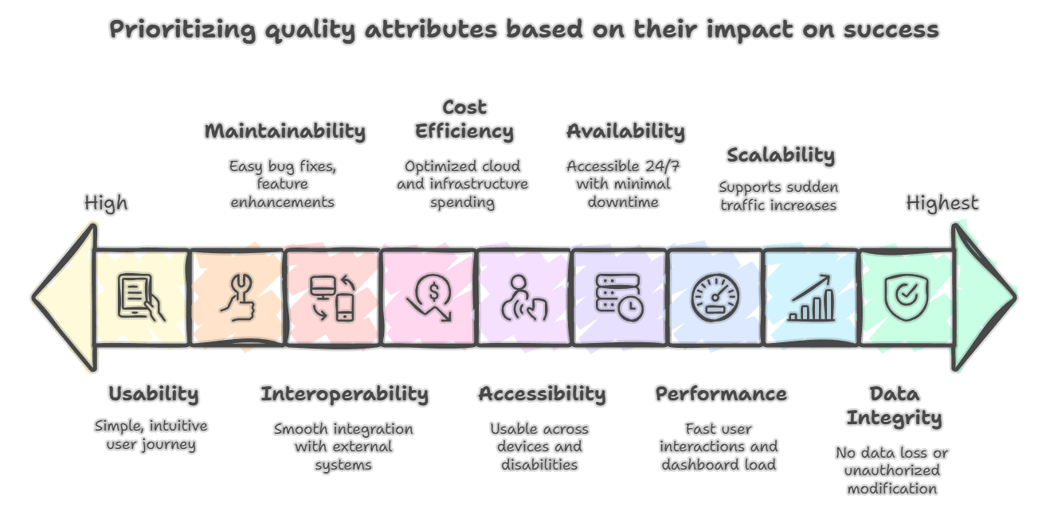

Quality Scenarios

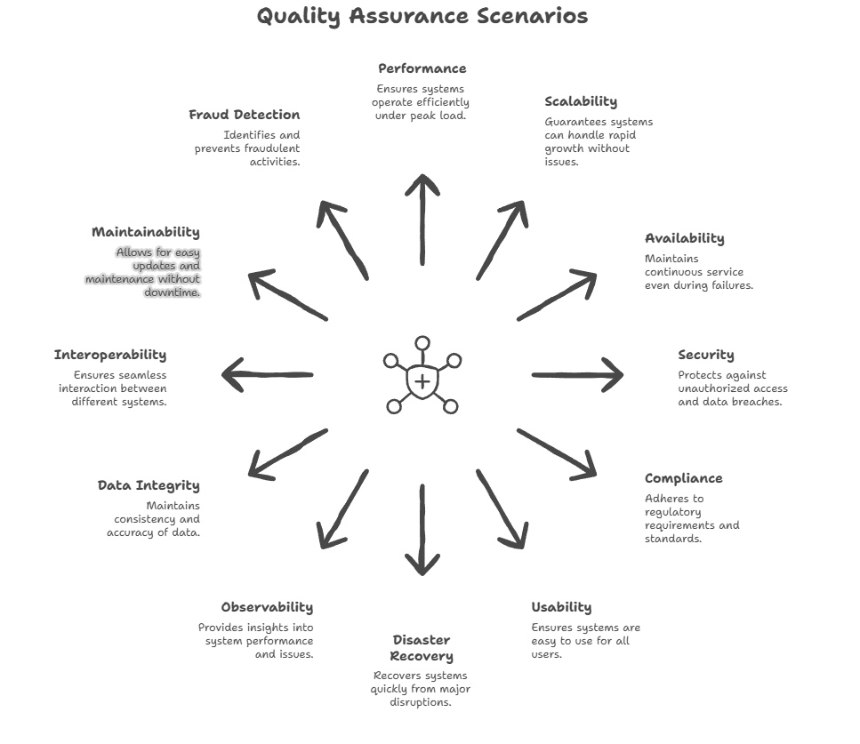

Risks and Technical Debt

A list of identified technical risks or technical debts, ordered by priority
Risk Type | Detail | Mitigation Strategies
Regulatory & Compliance Risks | Borrower or lender crossing RBI limits (₹10L borrower, ₹50L lender, ₹50k per borrower from one lender). | Integrate with all credit bureaus; enforce rules via centralized Business Rules Engine.
Regulatory & Compliance Risks | Escrow mismanagement by trustee bank leading to fund misuse or delay. | Partner with RBI-approved banks; automate reconciliation; independent trustee oversight.
Regulatory & Compliance Risks | Non-compliance with RBI audits and reporting formats. | Build standard MIS reports; automate audit trail (WORM storage).
Regulatory & Compliance Risks | Violation of India’s DPDP Act in handling personally identifiable information (PII). | Encrypt PII at rest and transit; tokenize Aadhaar/PAN; enforce strict RBAC; periodic VAPT.
Regulatory & Compliance Risks | Weak or delayed integration with credit bureaus (CIBIL, CRIF, Experian, Equifax). | Use multiple bureaus with failover; retries with backoff; human fallback if API fails.
Regulatory & Compliance Risks | New RBI regulation changes requiring urgent system updates. | Maintain a central Rules Engine; use feature toggles; architectural ADRs for adaptability.
Financial Risks | Borrower defaults on EMI leading to lender losses. | Use AI credit risk scoring; escrow-managed EMI collection; promote lender diversification.
Financial Risks | Lenders losing trust if repayment rates are poor. | Provide regular reporting; transparent risk scoring; insurance/guarantee funds (if applicable).
Financial Risks | Fraudulent borrowers submitting fake documents or KYC. | Implement strong KYC (PAN, Aadhaar, OCR + video); anomaly detection (duplicate PAN/IP/device).
Financial Risks | Collusion between borrower and lender for illegal transactions. | Continuous fraud monitoring; transaction pattern analysis; alerts for unusual behaviour.
Financial Risks | Economic downturn leading to high borrower default rates. | Use dynamic credit risk adjustment; stress testing; risk-based pricing; diversification.
Financial Risks | Misallocation of EMI repayments due to system or escrow failures. | Automated escrow logic; double-entry accounting; reconciliation dashboards.
Technology & System Risks | System downtime during loan disbursement or EMI collection. | Use multi-AZ Kubernetes; implement auto-healing; health checks; failover DB replicas; DR site.
Technology & System Risks | Scalability bottlenecks during seasonal spikes. | Horizontal scaling; partitioned Kafka topics; database sharding if necessary.
Technology & System Risks | Data loss or corruption in PostgreSQL or Kafka. | WAL archiving; point-in-time recovery backups; Kafka replication; S3 snapshots.
Technology & System Risks | Payment gateway failures (e.g., UPI, netbanking). | Multi-provider strategy; retries with circuit breakers.
Technology & System Risks | AI/ML scoring producing biased or inaccurate results. | Use champion-challenger models; fairness tests; periodic retraining with new data.
Technology & System Risks | Data breaches exposing PII or financial data. | WAF, IDS/IPS, DLP; encryption; security audits; bug bounty programs.
Technology & System Risks | Poor mobile app performance under low bandwidth conditions. | Offline-first design; local caching; optimized APIs; lightweight UI.
Technology & System Risks | Dependency on external APIs (KYC providers, credit bureaus, banks). | Circuit breakers; asynchronous queue fallback; caching of last-known values.
Operational Risks | Delays in borrower KYC verification affecting onboarding speed. | Integrate with multiple KYC providers; use AI/OCR automation; fallback to manual verification.
Operational Risks | Human approver backlog if AI is not fully automated. | Hybrid AI + human model; auto-approve low-risk loans; queue borderline cases.
Operational Risks | Failure in reconciliation between escrow and platform records. | Daily automated reconciliation; manual audit reports.
Operational Risks | Mismanagement of secondary marketplace loans. | Use smart contracts and ledger-based ownership tracking; enforce validation rules.
Operational Risks | Inadequate fraud monitoring or anomaly detection. | Dedicated fraud ML service; real-time alerts; anomaly detection pipelines.
Operational Risks | Vendor risk due to trustee bank, payment gateway, or KYC provider downtime. | Multi-vendor strategy; SLAs in contracts; fallback to alternate providers.
Business & Strategic Risks | Low lender adoption due to trust concerns. | Incentives like bonus interest; transparent ROI dashboards; educational campaigns.
Business & Strategic Risks | Borrowers prefer banks/fintech apps over P2P platform. | Offer faster disbursals; flexible EMI; simplified application process.
Business & Strategic Risks | High marketing spend without enough borrower-lender matches. | AI-based borrower-lender matching; creditworthiness insights to increase match rates.
Business & Strategic Risks | Negative media coverage if defaults or fraud increase. | Transparent communication; robust PR; strong compliance enforcement.
AI/ML Specific Risks | Model drift leading to less accurate credit scoring over time. | Implement drift monitoring; retraining pipeline; shadow deployments before model replacement.
AI/ML Specific Risks | Lack of explainability in AI decisions causing regulatory/legal issues. | Use SHAP/LIME explainability; provide reason codes for loan approvals/declines.
AI/ML Specific Risks | Data bias causing unfair scoring of certain borrower segments. | Bias detection; fairness audits; human review on flagged cases; use diverse training data.
AI/ML Specific Risks | Poor data quality leads to unreliable scoring | Strict data validation, pipeline for outlier/error handling, continuous feedback loop
Infrastructure Dependency | AI service downtime affects business ops | Use health checks, redundant instances, failover mechanisms

The advantage we have, to go with the newly designed system as compare to current market products is as below

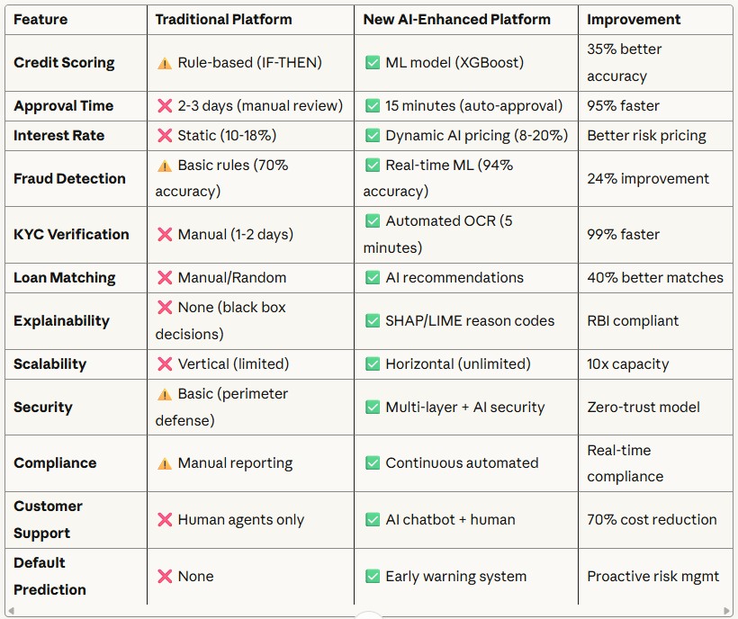

Glossary

Below are some of the terms used frequently in this document.

P2P Lending = Direct borrowing/lending, bypassing banks

KYC = Know Your Customer process for identity verification

Escrow Account = 3rd party account, holding funds during transactions

EMI = Equated Monthly Instalment for loan repayment

Polyglot = Use of multiple technology stacks/databases

RBI = Reserve Bank of India, financial sector regulator

Marketplace = Secondary trading of loan assets

JWT = JSON Web Token, for authentication

